A square paper napkin is folded so that the corner P coincides with the midpoint of an opposite edge as shown in the diagram.
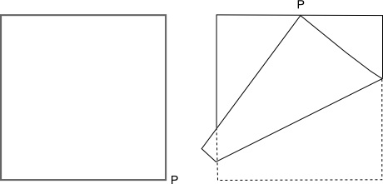
Investigate the three triangles that are formed by folding in this way (where there is a single thickness of the paper).

