Can you rearrange the statements below to find the area of the quadrilateral AQOP?

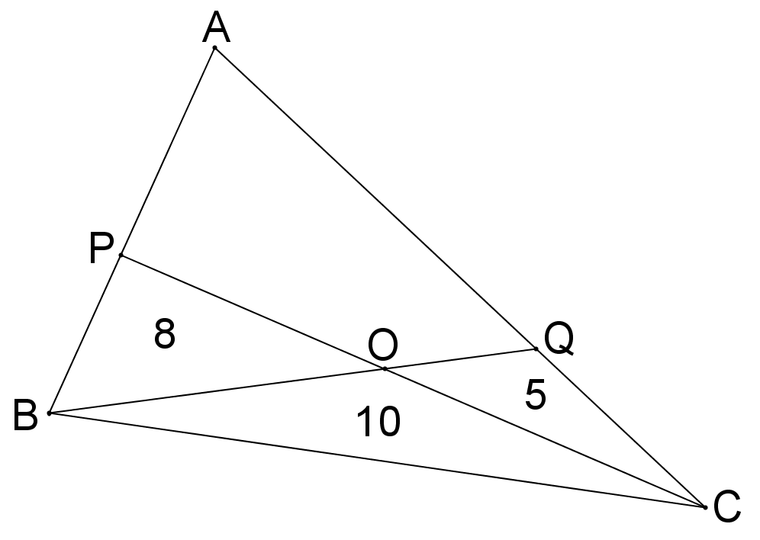

A | Substituting this back into equation (1) gives $E=12$.
B | Triangles $QAO$ and $OAB$ have the same height above the line $BQ$, so $\frac{F}{OQ}=\frac{E+8}{OQ}$.
C | Triangles $PAO$ and $OAC$ have the same height above the line $PC$, so $\frac{E}{PO}=\frac{F+5}{CO}.$
D | Combining these two equations gives $\frac{E}{8} = \frac{F+5}{10}$.
E | The area of quadrilateral $AQOP$ is $E+F = 10+12=22$.
F | Triangles $PBO$ and $OBC$ also have the same height above the line $PC$, so $\frac{8}{PO}=\frac{10}{CO}$.
G | Solving for $F$ gives $F=10$.
H | Doubling equation (2) and rearranging gives $10E = 20F - 80$.
I | Draw in the line $AO$. Label the area of triangle $AOP$ as $E$, and that of $AOQ$ as $F$.
J | Clearing denominators gives $10E = 8F+40$. Call this equation (1).
K | Clearing denominators gives $10F = 5E+40$. Call this equation (2).
L | Combining these two equations gives $\frac{F}{5} = \frac{E+8}{10}$.
M | Triangles $QCO$ and $OBC$ also have the same height above $BQ$, so $\frac{5}{OQ}=\frac{10}{BO}$.
N | Substituting this into equation (1) gives $20F - 80 = 8F+40$.

