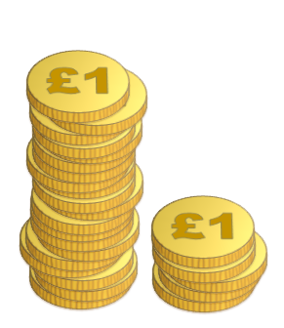
Last weekend Mrs Jenkins won £25 and she gave her winnings to her five children.
She gave her first child £1 plus $\frac{1}{6}$ of the money remaining.
She gave her second child £2 plus $\frac{1}{6}$ of the money remaining.
She gave her third child £3 plus $\frac{1}{6}$ of the money remaining, and so on...
Without doing any calculations, which child do you think ended up with the most money?
Work out how much each child received. Are you surprised?
Mrs Hobson also had some money to share with her family.
She gave her first child £1 plus $\frac{1}{5}$ of the money remaining.
She gave her second child £2 plus $\frac{1}{5}$ of the money remaining.
She gave her third child £3 plus $\frac{1}{5}$ of the money remaining, and so on...
How much money did she have to share out if all the children received the same amount?
How many children were there in the family?

In a family with eight children, the mother wants to give each child a lump sum plus a fraction of the remainder, in the same way that Mrs Jenkins and Mrs Hobson did.

How much money will she share out, and what fraction will she use each time, in order to share the money equally?

Extension

Imagine someone had n children.
How much money do you think you would need, in order to give every child an equal share using the method above?

Can you show that the first child will receive $\frac{1}{n}$ of the total?
Can you show that the second child will also receive $\frac{1}{n}$ of the total?
What about the third? The fourth? The k^{th} child? ...

