A classical Greek problem was to find a way to trisect an angle using just a ruler and compass. However, this is impossible.
It is possible though, to trisect an angle using a carpenter's square, or an L shape. You can see this in the video at http://nrich.maths.org/726 , or by following the diagrams below.
Step 1  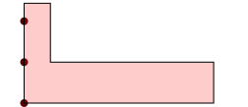 | Step 2  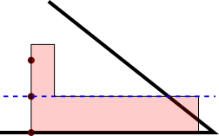
Step 3  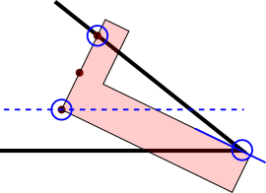 | Step 4  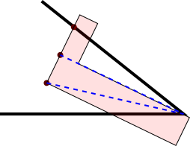
Can you explain why this works?
Can you extend the idea to trisect an obtuse angle?

