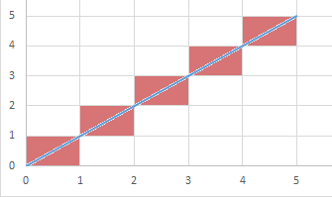

If I join the points (0, 0) and (5, 5) the line segment passes through five grid squares.

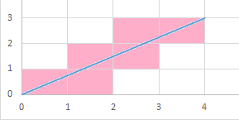

If I join the points (0, 0) and (4, 3) the line segment passes through six grid squares.

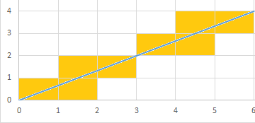

If I join the points (0, 0) and
(6, 4) the line segment passes through eight grid squares.

Can you find a relationship between the coordinates of the end of the line segment and the number of squares it passes through?

If I draw the line segment joining the origin to the point (50, 37) how many grid squares will it pass through?

If I draw the line segment joining the origin to the point (96, 72) how many grid squares will it pass through?

Can you find a line segment that passes through exactly 24 squares?
Can you find more than one?

Can you work out how many grid squares a line segment passes through, if you are given the coordinates of the two endpoints, where neither is at the origin?

