The graphs of fifteen parabolas are sketched on the axes below.
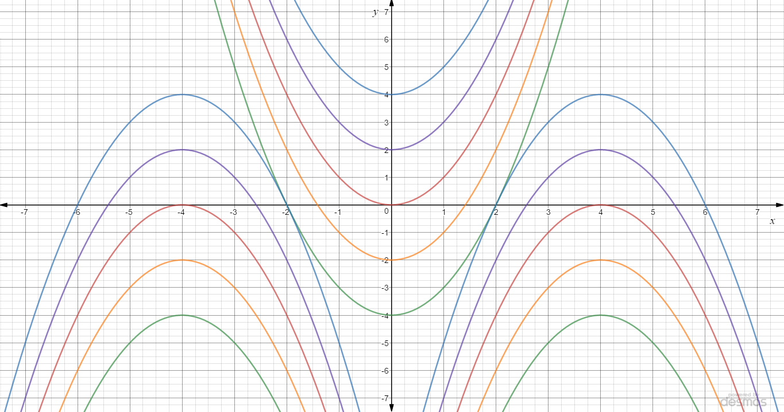
One of them has the equation $y=x^{2}$, and another is $y=-{\left(x-4\right)}^{2}$.
Can you find the equations of the other parabolas?

