Alison started by choosing a triangular number, multiplied it by 8, and added 1. She noticed something interesting about her results...

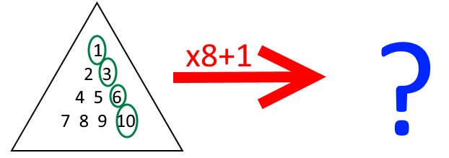
Try a few examples. Can you make a conjecture?
Once you've made a conjecture of your own, turn the page over to read what Alison noticed.
"If T is a triangular number, 8T+1 is a square number."
Can you prove the conjecture?
Claire thought that she could use a picture to prove this conjecture. Can you use her picture to create another proof to show that the conjecture is true?
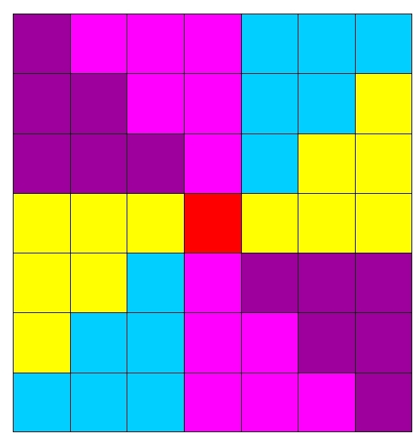
I wonder if there are any integers $k$ where $8k+1$ is a square number but $k$ is not a triangular number...
Can you prove that if $8k+1$ is a square number, $k$ must be a triangular number?
Can you use your theorem to devise a quick way to check whether the following numbers are triangular numbers?
6214, 3655, 7626, 8656

