Catrina wants to know how many football cards she has collected.
She has filled up five pages of her scrapbook and on each page there are four cards.
Can you show how you would find out? You might draw a picture or do some jottings or...
When you have had tried something yourself, take a look at what some other children did:

Kerstin:

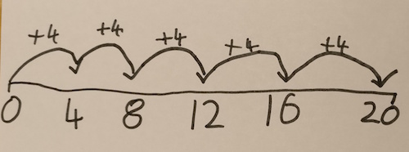

Isaac:

I used counters to represent the football cards. I made an array:

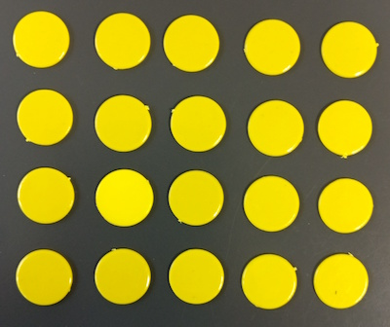

Wai:

I drew a picture:

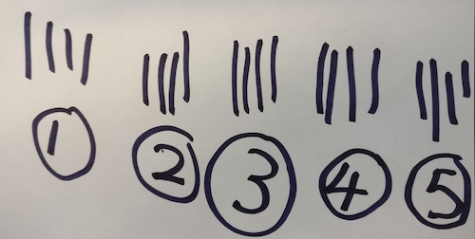

Danesh:

I thought a double number line would help me work out the answer:

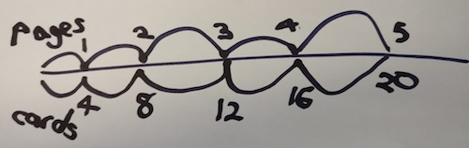

What is the same about the four ways? What is different?
How does each way compare with what you did?
Which one do you prefer and why?

