If I gave you a list of decimals, you might find it quite straightforward to put them in order of size. But what about ordering fractions?
A man called John Farey investigated sequences of fractions in order of size - they are called Farey Sequences.
The third Farey Sequence, F3, looks like this:
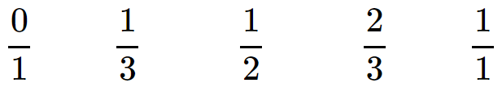

It lists in order all the fractions between 0 and 1, in their simplest forms, with denominators up to and including 3.
Here is F4:
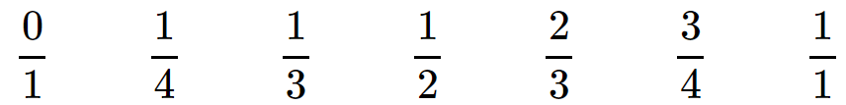

Write down F5.
Which extra fractions are in F5 which weren't in F4?
Which extra fractions will be in F6 that weren’t in F5?
Where will they appear in the sequence?
There are lots of questions you could explore about Farey Sequences. Here are just a few that we thought of:
- How many extra fractions are there in F11 that aren’t in F10?
- How many extra fractions are there in F12 that aren’t in F11?
- Is every Farey Sequence longer than the one before? How do you know?
- Is there a way of working out how many fractions there will be in the next sequence?
- So far, all the Farey Sequences except F1 have contained an odd number of fractions. Can you find a Farey Sequence with an even number of fractions?

