If I gave you a list of decimals, you might find it quite straightforward to put them in order of size. But what about ordering fractions?
A man called John Farey investigated sequences of fractions in order of size - they are called Farey Sequences.
The third Farey Sequence, 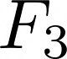, looks like this:
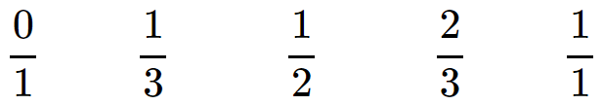

It lists in order all the fractions between 0 and 1, in their simplest forms, with denominators up to and including 3.
Here is 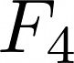:
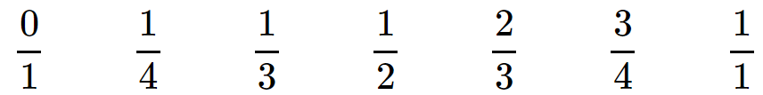

Write down 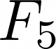.
Which extra fractions are in which weren't in ?
Which extra fractions will be in 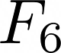 that weren’t in ?
Where will they appear in the sequence?
There are lots of questions you could explore about Farey Sequences. Here are just a few that we thought of:
- How many extra fractions are there in 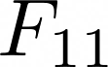 that aren’t in 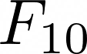?
- How many extra fractions are there in 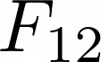 that aren’t in ?
- Is every Farey Sequence longer than the one before? How do you know?
- Is there a way of working out how many fractions there will be in the next sequence?
- So far, all the Farey Sequences except 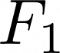 have contained an odd number of fractions. Can you find a Farey Sequence with an even number of fractions?

