Can you use the diagrams below to create 4 different proofs that, whatever the orientation of the red square, it covers a quarter of the blue square?

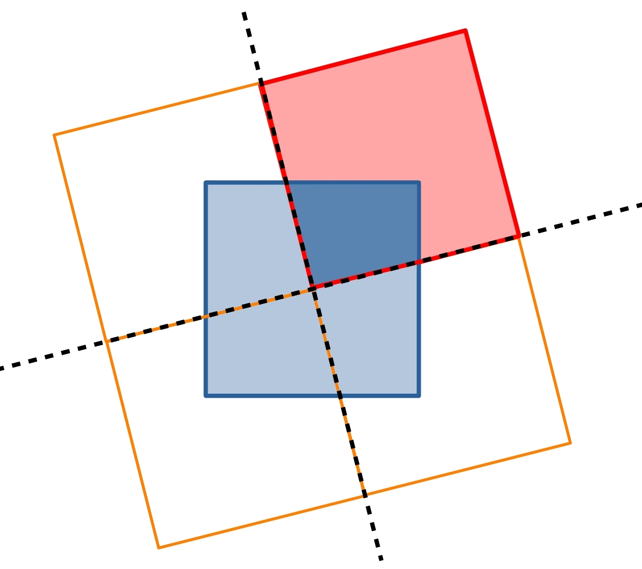  Method 1 | 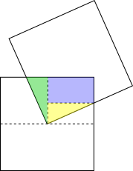  Method 2
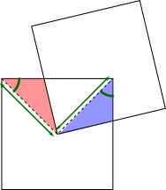  Method 3 | 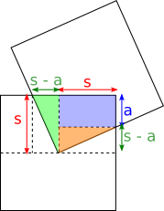  Method 4

