Skeleton shapes are made with balls of modelling clay and straws.
This shows a cube and a skeleton cube:
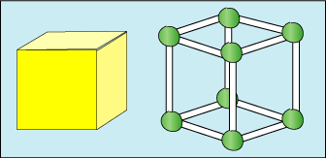
How many balls of modelling clay and how many straws does it take to make the cube?
Here are some piles of modelling clay balls and straws:
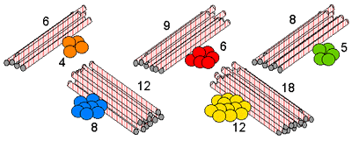
Look at the shapes below and decide which piles are needed to make a skeleton of each shape.
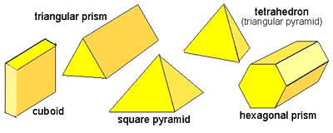
How do you know which piles go with which shape?

