A recurring decimal is a decimal with a digit, or group of digits, that repeats forever.
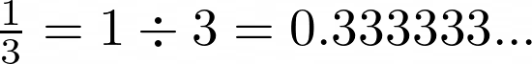
For example, ..with the 3s repeating forever.
We can write this as .

Imagine I started with the number
How could you write in terms of ?
Can you find two different ways?

Can you create an equation, and then solve it to express as a fraction?
Now let's consider ., where the digits 2 and 5 keep alternating forever.
This can be written as , with dots over the first and last digit in the repeating pattern.
How could you write in terms of , in two different ways?
Can you create an equation, and then solve it to express .as a fraction?
Now try writing the following recurring decimals as fractions:
Can you describe a method that will allow you to express any recurring decimal as a fraction?

