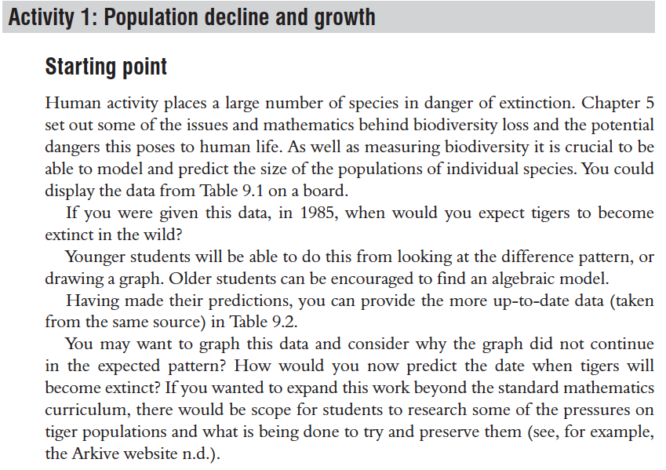

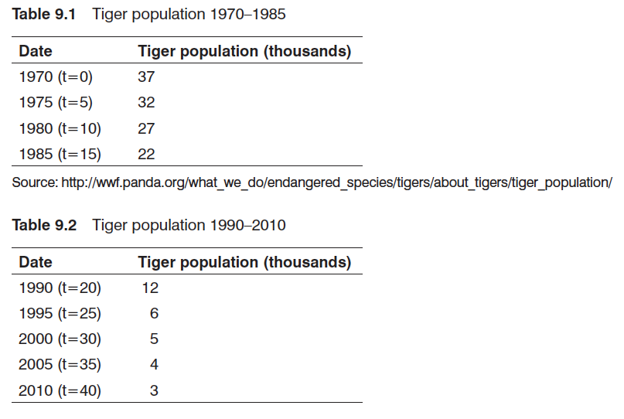

Possibilities

Students could be invited to gather data on the numbers of other species (including humans). What predictions can be made about the future? What species (other than humans) are thriving? Why?

