Twenty Divided Into Six
First we added all the numbers from 1-20 and divided it by 6 because I needed 6 piles. This got us to 35. So then we knew that each pile needed to add up to 35.
We then made some number cards. We used the six biggest numbers (except not 15 because we needed this to add to 20 to make 35) as the first number in each pile.
We then started to put the number cards together under the headings to make the total of 35, using trial and error until we found this solution.

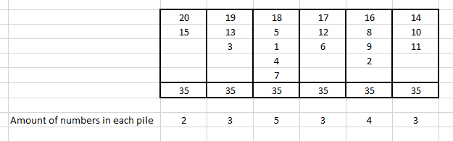
As you can see, the piles are not all unequal. Three of the piles have 3 numbers in.
However, we do not think it is possible because there aren’t enough numbers to make all the piles unequal.

In order to have six unequal piles (with a total of 35) you would have to have 27 numbers before seeing if it would work.

