Step 1
First, you have a set of cards that are labelled 1-20 also they have to be unequal and in 6 piles, the numbers have to add up to a certain number, and this is for every pile.
Step 2
Next, you see if all the numbers add up to the certain number you are looking for, if you don’t get it the first time then keep estimating and keep checking if that number works.
STEP 3
Once, you think you have the number try it out and if you get the number 35 you need to put them into six piles.
Step 4
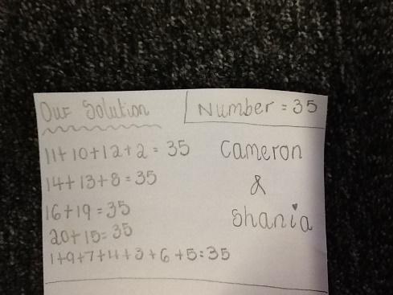
Now you need to list all your numbers and get them down on a piece of paper, our one looks like this.

