Domino Square
We thought if we made the corners 1 each they would equal 2, so the middle 2 dominoes would have to equal 6 altogether.
We tried this but the 3-3 domino meant this would only work with the 0-0 which we needed elsewhere.
We then tried this (see below) but although 3 sides equalled 8 unfortunately one side added up to 9 see Photo 1
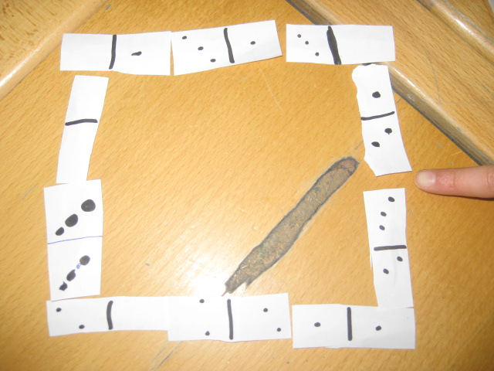

We swapped some of the tiles using trial and error and successfully completed the task, see photo 2
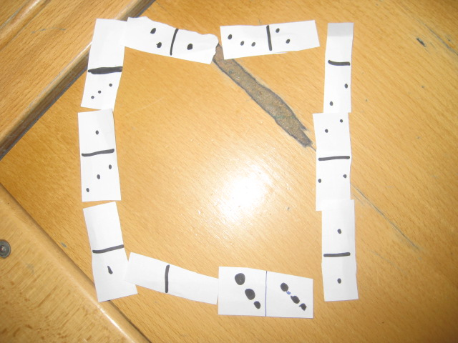

Audrey, Esha and Lauren
Year 4 North London Collegiate School

