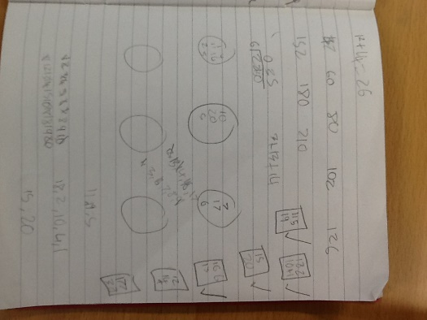
Twenty Divided Into Six
- First, we add all the numbers in the 20 which equals 210. We used column addition to work this calculation out.

- Next, we divide 210 by 6 which equals 35. We used the bus stop method to divide this one by six. We learnt this in class.

- After that, you arrange all numbers into piles of 35. We put the numbers in circles because it was more efficient. Also, we could

- First pile will be 11, 5 and 19.
- Second pile will be 18, 2, 10, 4 and 1.
- Third pile will be 15 and 20.
- Fourth pile will be 16, 6 and 13.
- Fifth pile will be 12, 14 and 9.
- Last pile will be 17, 3, 7 and 8.

By Dylan and Molly.

