Plan
Hypothesis: February is the wettest month
We are going to use a bar chart to represent the data.
The averages we will use is going to be the mode (to find out which month has the most rainfall per year). We are also going to find out the spread of the data (to tell us the difference between the month with the most and least rain).
We are going to look at 10 different years in consecutive order. These years be 1980 – 1990. The pieces of data that we’re using are form two of the three places (Shawbury and Eastbourne).
We are expecting to find that the most rainfall occurs in the autumn/winter months (August-March) as that is generally the coldest/wettest time of the year as this is where we have recognised the most rainfall.

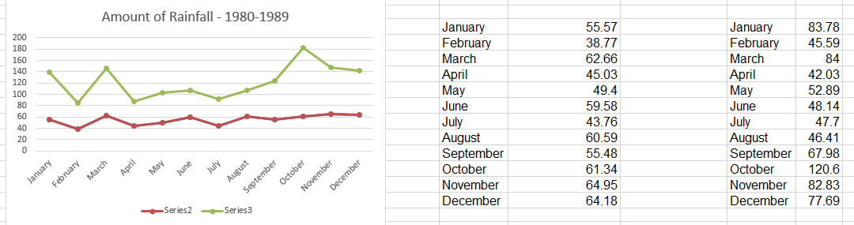
Line Graph

Analysis
This graph shows us the amount of rainfall in the years of 1980 to 1989 in the two different locations (Shawbury and Eastbourne). The data on the graph shows that in Shawbury, February was in fact the driest month, with 38.77mm! This, consequently, is the complete opposite to what our hypothesis states.
In Eastbourne, February is shown to have had 45.59mm of rainfall which is placed in the middle of April and August which shows that it was not in fact the wettest or driest month.

Conclusion
In conclusion, our hypothesis is incorrect. This is evident in the data that we have collected and the graph that we have produced. The graph states that February is among one of the months with the least rainfall, and that on average, the month that has the most rainfall per year is October.

