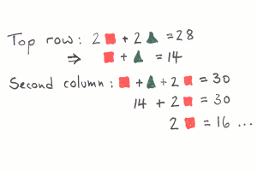
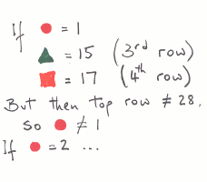
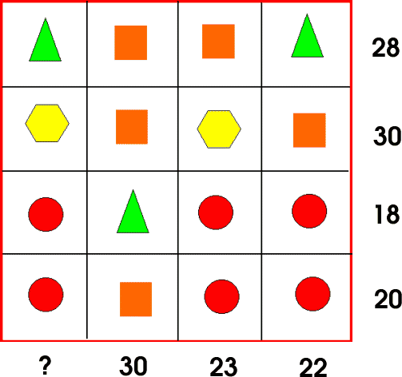
Z=Hexagon
W=Circle
X= Square
Y= Triangle
Top row: If 2 x =16 the 2y = 12 so y = 6 and x = 8
Second row: if x = 8 then z = 7 as it is proven in the second row.
Third row: if y = 6 then W= 4 as calculated on row 3
Now we have all of the calculation we can now find the missing column which is if you add 2 W one Z and a Y then your total is 21

If circle = 2, triangle = 12 and square = 14 but column 2 = 30.
If the circle was 3 then the Square would be 11 and the triangle would be 9 but column 3 = 30
If the circle was 4 then the square would be 8 and the triangle would bee 6 which is correct as column 3 and the first row add up correctly
Method 1
Method 2

To find the question mark I would simply use algebra to work out the following however the question us to develop the following answers. The answers to the following are shown below:
Square=8 Triangle=6
Circle=4 Hexagon=7
What’s it Worth?

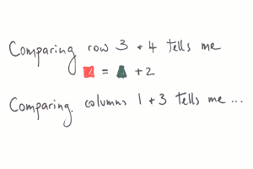
Method 3
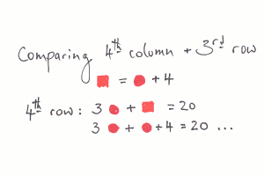
1
If triangle = 9 then square= 5 but then the second column = 30
If triangle = 8 then square = 6 but then the second column = 30
If triangle = 7 then square = 7 but then the second column = 30
If triangle = 6 then square = 8 which agrees with column 2
When knowing what triangle and square is we can now find out what the rest is for example finding what the circle is, you could minus the square form the total of the row 4 then that shall be 12/ amount of circles = 4 so the circles are four and now the hexagon. Minus 2 squares by the total of the 2nd row which shall be 14/ the amount of hexagons which gives you the total of 7 and now to find column which shall be 2 circles + hexagon + triangle which would be 21.
Method 5
3 circles + a square = 20 so
3 circles + a circle+4 = 20
So 4-20 = 16/4 circles = 4 so a circle = 4 so that means we can now work out row 3&4
3 circles= 12- 18 and 20 = 6 & 8 which would mean that triangle= 6 and square=8 so knowing this we can work out the hexagon on column 3, square + 2circles =16 so 23-16=7 so to work out column 1 you have to do 2 circles plus one hexagon and one square which would come to a total of 21.
Method 4
Comparing columns 1=3 tells me that column 1 is 2 less than column 3 which means that the answer is that column 1 is 21
1

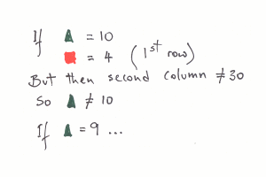

1 circle = 4 so in row 3&4 you can find out triangle and square. £circles are 12 – 18 & 20 getting 6 and 8 which would mean that square is 8 and triangle is 6, now to find out the hexagon which would meant to have to times 2 by square to get 16 -30 = 14/ number of hexagons = 7 so a hexagon = 7 to find the first column you would have to do by these steps 2circle +hexagon + triangle = 21
Method 6
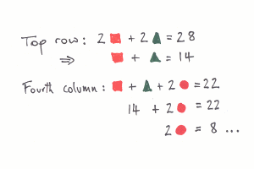
1

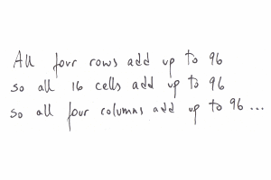
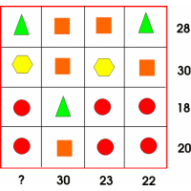
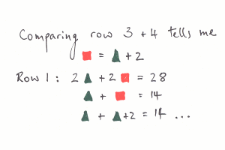
So if that is the case then the first column shall be 21 as 96 – 55=21.

Armand
Dave
Khusul 8C
Method 8
2 – 14 = 12, 12/ 2triangles = 6 = 1 triangle
For row 1: 28 – 2 triangles = 16/ the amount of squares = 8 per square
For row 3: 18-triangle = 12/ amount of circles = 4 per circle
For row 2: 30- 2squares = 14/ amount of hexagons = 7per hexagon
Column 1: triangle+hexagon+2circles= 21
Method 7

