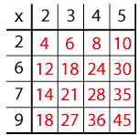
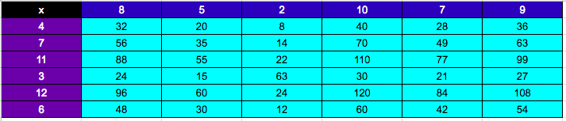
Your Questions:

1) Can you see how it has been constructed?
2) Why are some numbers in black and some in red?
3) Can you explain why the red 6 is in that particular square?
4) Why is there a 45 in the right-hand corner?
Can you explain why the red 6 is in that particular square?
Why is there a 45 in the bottom right-hand corner?
Can you explain why the red 6 is in that particular square?
Why is there a 45 in the bottom right-hand corner?
Can you explain why the red 6 is in that particular square?
Why is there a 45 in the bottom right-hand corner?
Can you see how it has been constructed?
Why are some numbers in black and some in red?
Can you explain why the red 6 is in that particular square?
Why is there a 45 in the bottom right-hand corner?

Our answers to your questions:
- Yes, we can see how the grid has been constructed: horizontal x vertical black numbers = red number or another way to explain is: black number x black number = red numbers e.g: 2 that is horizontal x 6 vertical=12 in red

2) The red numbers are the answers to the black numbers e.g 2x2= 4, 2x3 = 6, 2x4=8, 2x5=10 and so on

3) The red 6 is in that square because 2x3=6

4) There is a 45 in the right-hand corner because 9x5=45
Mystery Matrix
Our solution:

