In order to find the area of a square on dotty paper use this formula x^2+y^2 where the length is on a slant. Make one of the slanted sides into a right-angled triangle whereas, the other sides are positive integers. The sides that aren’t part of the square are x and y.
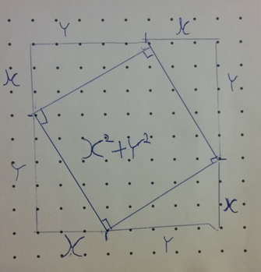
To prove this you could either find one side using Pythagoras theorem to find its sides or you could find the area of the larger square then subtract the triangles.
Proof 1 :(x+y)(x+y)=x^2+y^2 +2xy Area of all the triangles=1/2 xy*4=2xy
x^2+y^2+2xy-2xy=x^2+y^2=Area of square
Proof 2: As l^2=area, we could use a^2+b^2=c^2 and change it to x^2+y^2=area of square.

