How many different paths are there from A to B?
As he is only travelling north or east each time, the number of paths is greatly restricted.
A tree diagram may help you to understand the steps.
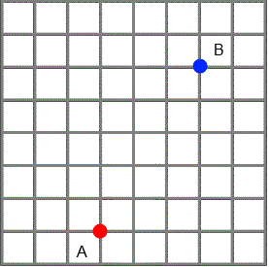
At point A, he has two options; north or east. Then, at both of the subsequent points he has the same choice.
But, you cannot assume he has this choice each time.
He cannot move out of the rectangle in the picture, as he would be then unable to reach point B without travelling south or west. This would not be one of the shortest routes and hence would be a poor choice.
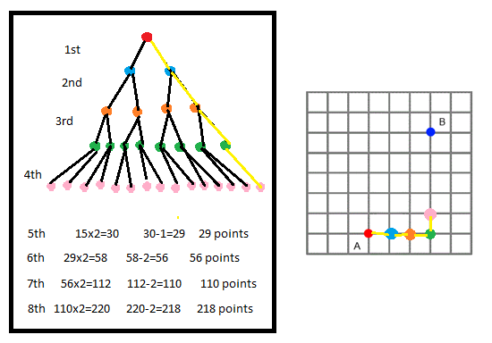
With this in mind, whenever he reaches an edge of the rectangle, he will have not two choices but one.
As the rectangle is 3X5, this occurs at each decision once after the 3rd decision, and twice after the 5th.
As shown in the diagram, this means that by the time he makes his last decision, there are 218 different ways he could have gone.

If I know the coordinates of two points, can I quickly work out how far I will have to walk to get from one to the other?
If you have to walk from point (a,b) to point (A,B) the minimum distance you will have to walk will always be A-a + B-b. Where A>a, and B>b. Or, the difference between the x coordinates, plus the difference between the y coordinates.
In this case,
If we use the left edge of the grid as the y axis and the bottom edge as the x axis, then the point A is (3,1) and the point B is (6,6).
6-3 + 6-1 = 8
This makes sense, as if you draw a rectangle with the points A and B as the opposite vertices, you can see that the sides are 3 and 5 units long. This is the minimum distance if you are unable to go diagonally.
Is there a quick way to find all the different paths from one point to another?
Is there a quick way to work out how many different paths there will be?
If I start at a point and only want to walk 6 blocks, how many possible places might I end up?
A good way to think about this is as a tree diagram.
At the starting point, you have 4 options of where to go.
Then at each subsequent point you have a choice of 3 paths (assuming you can’t double back on yourself)
So, the formula would be...
4x3^(n-1) Where n=the number of blocks you walk
In this case,
4x3^5= 972

