Cinema Problem by May Bails
To ensure £100 takings for 100 people you need to have 3 adults at £3.50, 47 pensioners at £1.00 and 50 children at 85p each. As shown below:
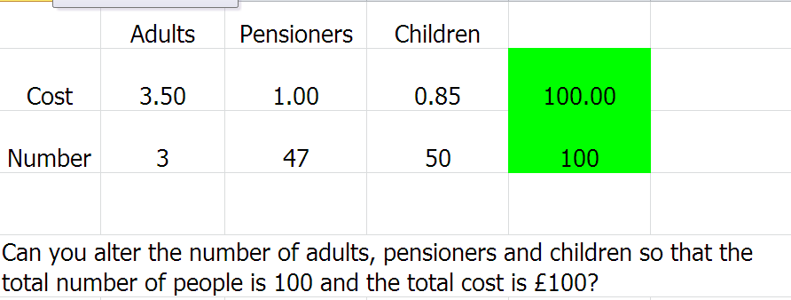
To ensure £100 takings for 100 people you need to have 10 adults at £4.00, 30 pensioners at £1.00 and 60 children at 50p each. As shown below:
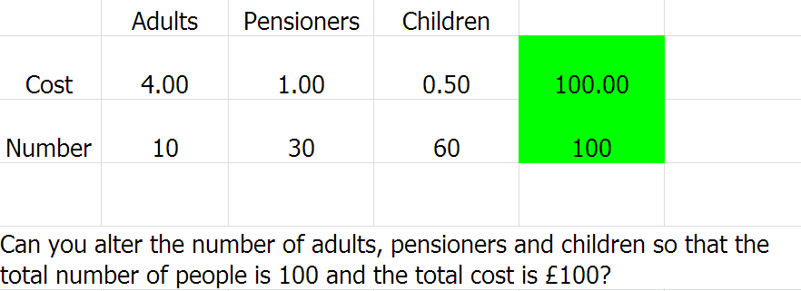
To ensure £100 takings for 100 people you need to have 4 adults at £5.00, 16 pensioners at £2.50 and 80 children at 50p each. As shown below:
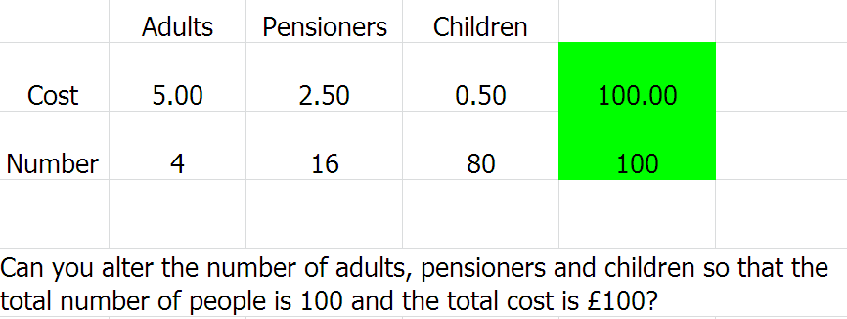
If you attempt to ensure there are 3 children for every adult. If you charge each person £1.00 you can have 75 children and 25 adults to make the £100 for 100people.
If the ratio of adults to children to pensioners needs to be 2:2:1. Then you can make the £100 by having 40 adults at £1.10, 40 children at £1.10 and 20 pensioners at 60p each. As shown below:
