Six Ten Total
THE MAIN CHALLENGE
We started off by using some grids to write out all the combinations we could think of and working out the totals.
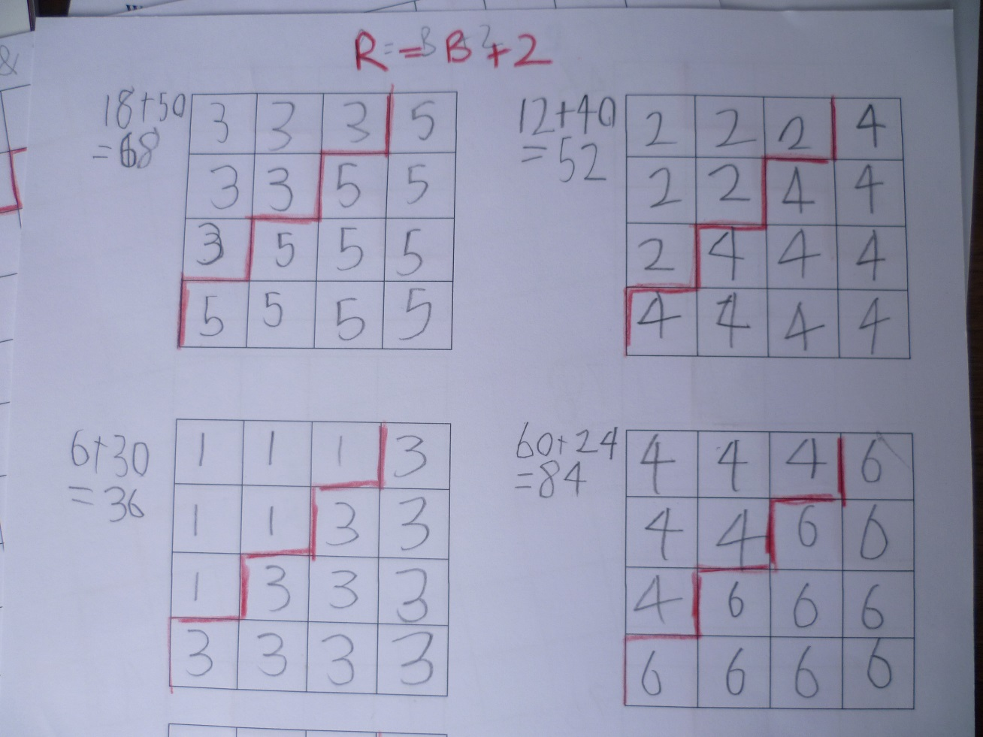

We then reversed these so the smaller number was on the bottom and worked out the totals for these.
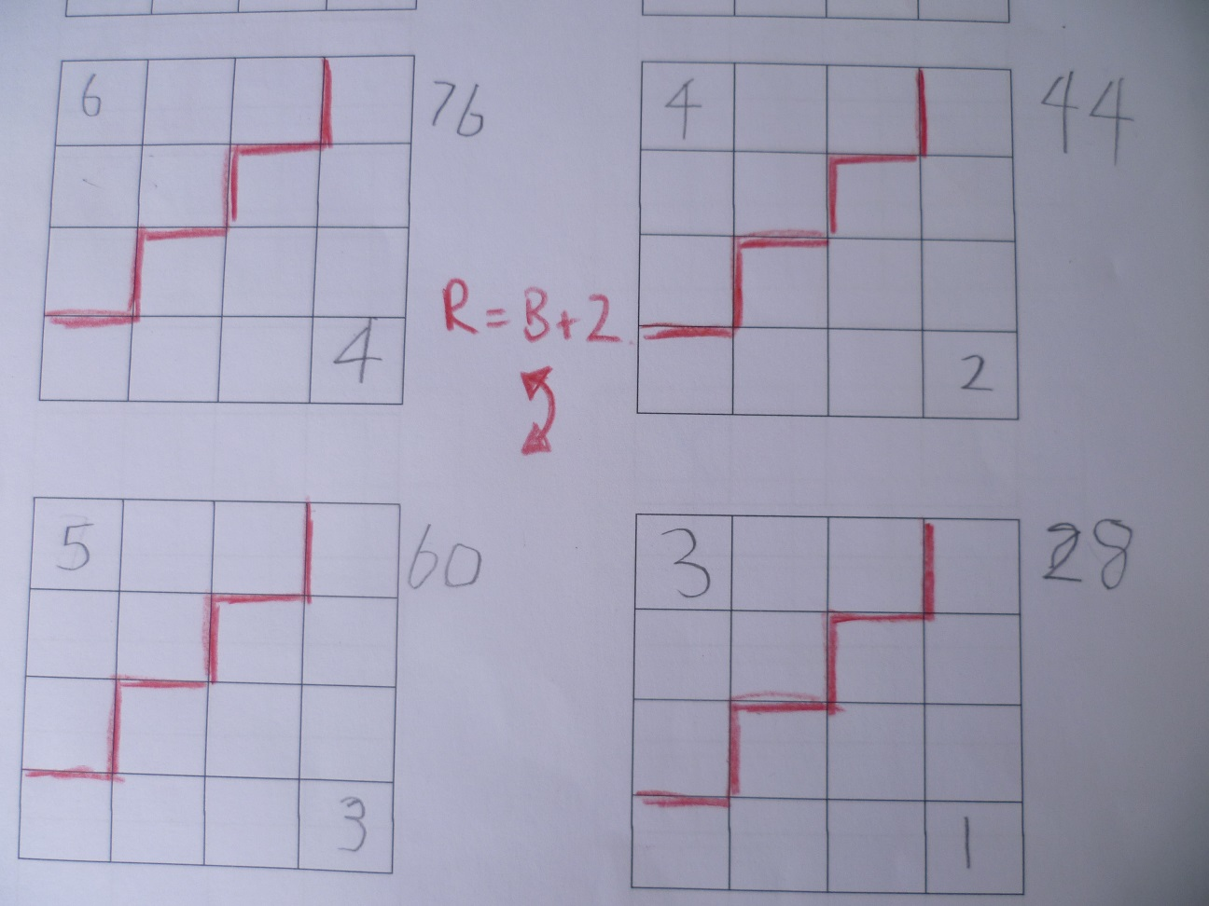

We noticed several things
1. There were 4 possible arrangements with the larger number on the red dice and then 4 others with the larger number on the blue dice.
2. All the totals were even numbers – we decided this was because there were an even number of dice (16). This is always true
3. When the larger of the 2 numbers was on the red dice, the totals were bigger because there were more red dice than blue. This is always true
4. The difference between successive totals was always 16. We decided that this was always true because there were 16 dice and we were increasing the number on each die by 1 every time.
TAKING IT FURTHER
We tried a difference of 3 between the numbers to see what happened. Here is one half of them.
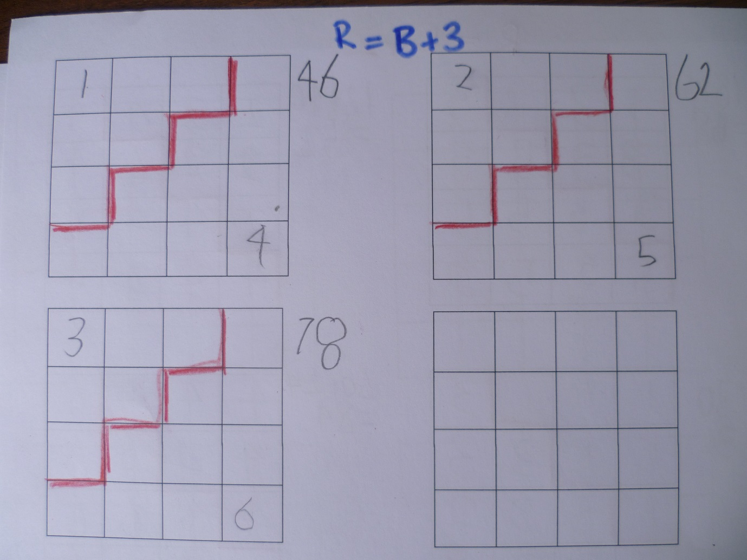

We noticed that there were less combinations possible and that the range of possible totals was narrower, 34 - 78 as opposed to 28 – 84 for those with a difference of 2.
AND NOW
So far we hadn’t come across a total of 42. The closest was 44 (6 x 4) + (10 x 2)
We decided to write an expression and solve it using trial and error. We took all the possible values of the sum of the red dice (being multiples of 10) and looked at what was left to see if any of the numbers were divisible by 6. The only possible solution was reds =2 and blues = 3
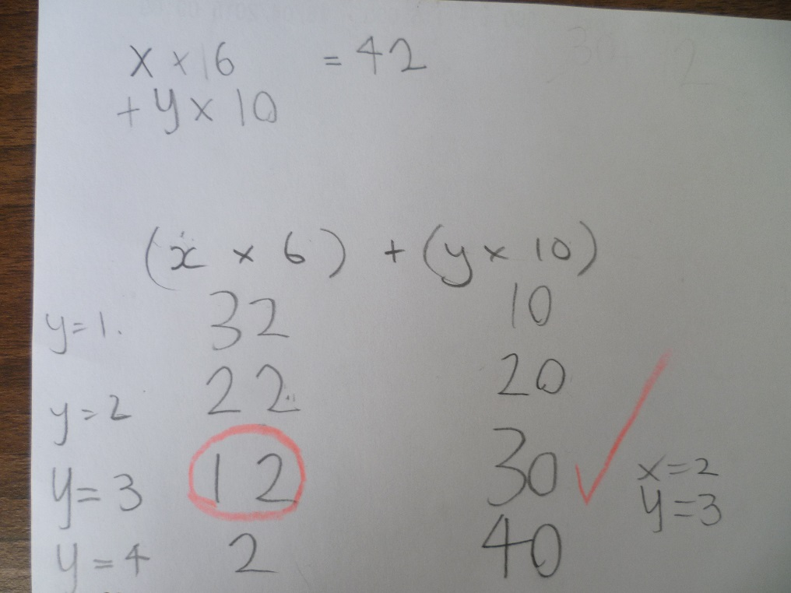
We then tried a 5 x 5 square and tried putting the diagonal in different places but soon realised that we could never get 42 as 1 & 3 gave odd numbers ( due to there being an odd number of dice) and any combination of 2 & 4 gave too big a total.
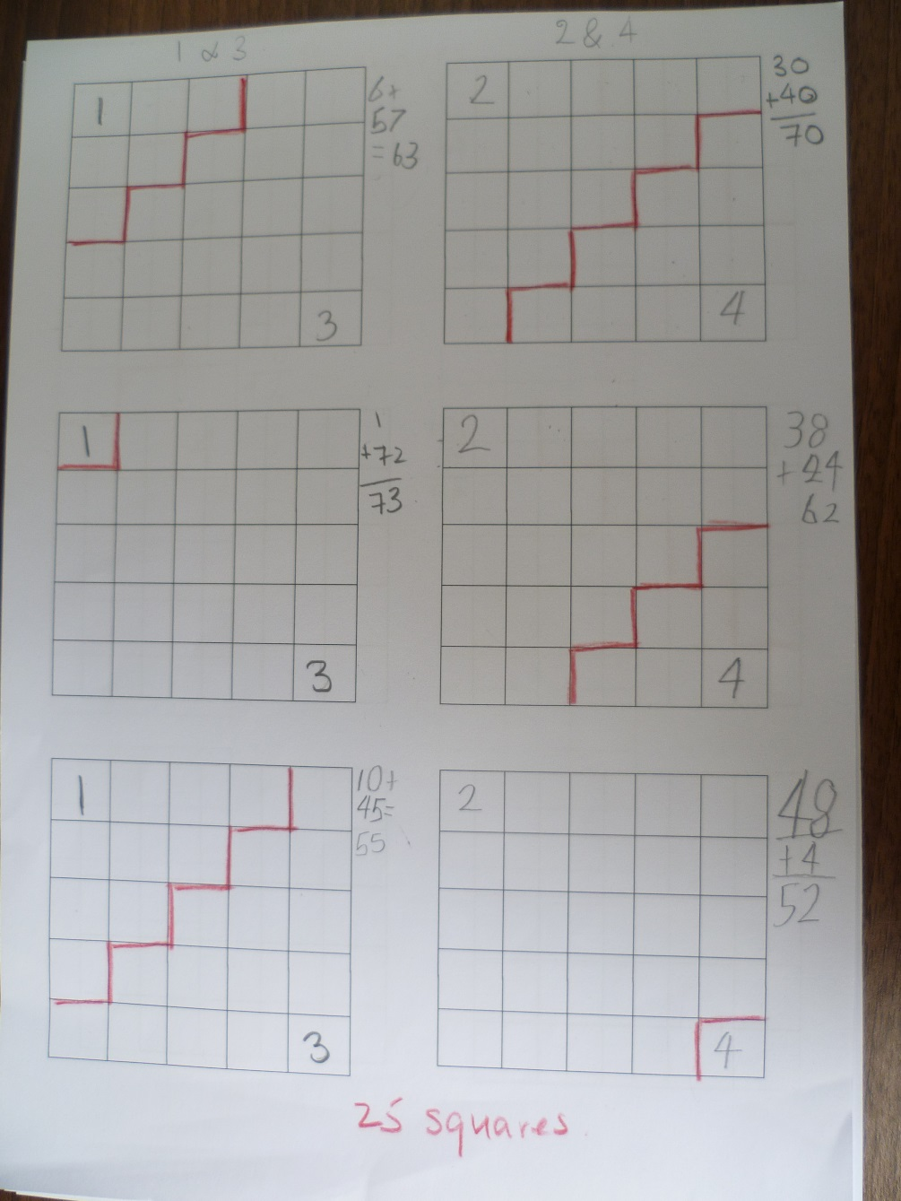
We tried removing the necessity to have a difference of 2, looking at 1 & 2 and got very close (6 x 1) + (19 x 2) = 44 and (10 x 1) + ( 15 x 2 ) = 40 but we couldn’t make 42. We realised that there was no point in looking at the reverse combinations as these would give us an odd number.

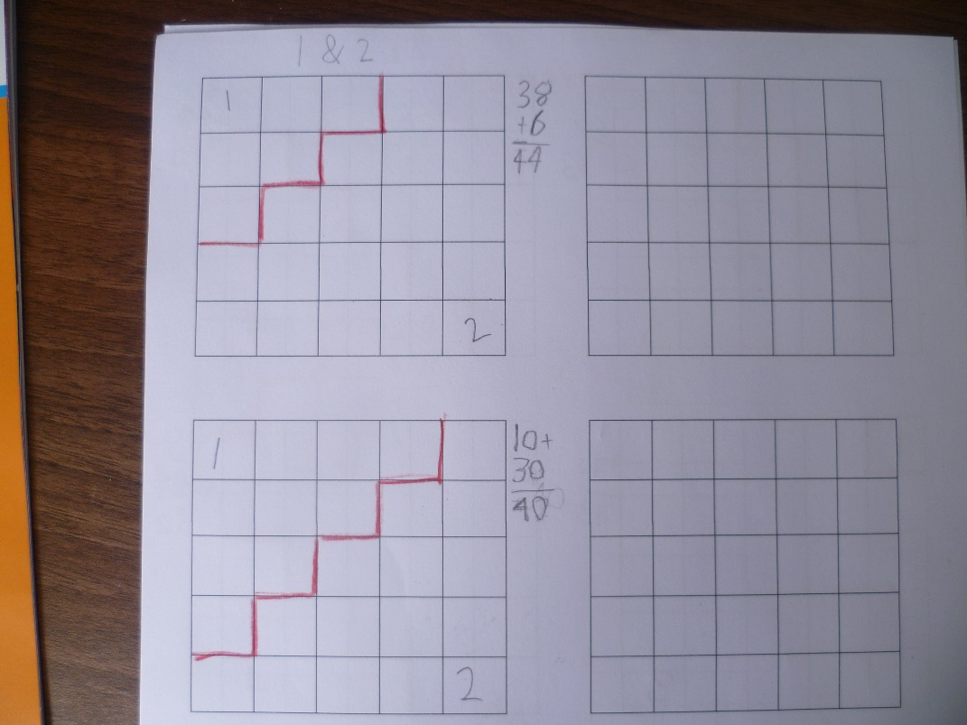

Having come to the conclusion that making the squares even bigger would not give us 42, we finally tried some 3 x 3 squares. We realised that we should only try even numbers as we had an odd number of squares. Almost immediately we found a combination that gave us 42 which is where we stopped. Lawrence said,” six sevens are forty-two” and if you look at the square you can see that in a way we do have 7 lots of 6 – 3 on the blue dice and then 4 in the 24 total on the red dice.

