Isla (Age: 10 years) – Young Minds Matters

Display Boards

Challenge A
The kitchen staff would like to use the hall for school dinners. They would like the display to be as long and narrow as possible, and at one end of the hall.

Solution Process
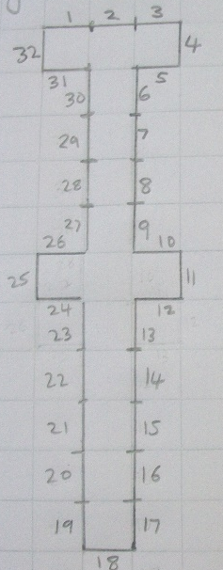
Isla began exploring the task using coloured matchsticks, so she could easily rearrange them if needed. It also allowed time to ensure that she understood and was following the rules.

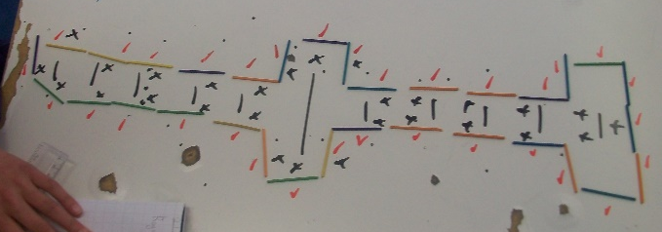
She quickly realised that she could not just have a 1 board wide oblong, as you could not have more than 5 boards in a row.

She then tried extending out both ways, once she had reached 5 boards in a row, making sure that she joined them at right-angles.

This created a shape that had a maximum width of 3 boards.

This was recorded onto squared paper. Numbers were added to show the individual boards and check that there were definitely 32 display boards in total.

Improvements
Once Isla had recorded the first possible solution, she then realised that she had not considered if the shape could be only 2 boards wide.

After some thought and a few tries, Isla discovered that she could create a wiggly shape that had a maximum width of 2 boards. As she was now confident with the rules, and knew the shape she was aiming for, she drew this straight into her book using the squares.

Solution
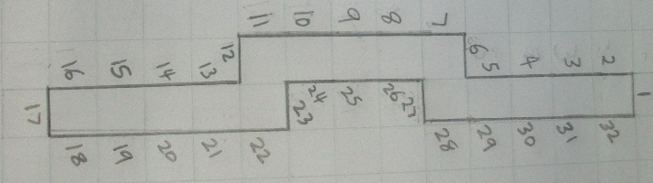
Isla is confident that this is the longest and narrowest shape possible because you cannot make one that is 1 board wide, as if you place more than 5 boards in a row they will fall over.

