QUADRATIC PATTERNS

For part 1,

$$2×3+3=9=3^{2}$$

$$5×6+6=36=6^{2}$$

$$4×5+5=25=5^{2}$$

If you take the product of two consecutive numbers and add to this the largest of the two numbers, the result is the largest number squared. Represented algebraically, this is

$$n\left(n+1\right)+(n+1)$$

Factorising,

$$(n+1)(n+1)$$

And we see this is

$${\left(n+1\right)}^{2}$$

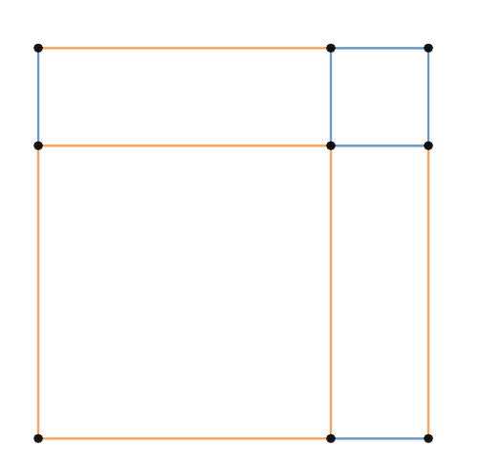
This is the diagram for the above pattern
$$1$$
I
D
$$n$$
$$n$$
$$n$$
$$n$$
$$1$$
$$1$$
$$1$$
$$1$$
$$n$$
$$1$$
$$n$$
F
G
H
E
C
A
B

For part 2

$$2^{2}-1\left(3\right)=1$$

$$3^{2}-2\left(4\right)=1$$

$$4^{2}-3\left(5\right)=1$$

If you choose three consecutive numbers, square the middle one and subtract the product of the other two, the result is 1. Represented algebraically, this is

$${\left(x+1\right)}^{2}-x(x+2)$$

Expanding the brackets,

$$x^{2}+2x+1-x^{2}-2x$$

Gathering like terms,

$$1$$

This is the diagram for the above pattern
$$x$$
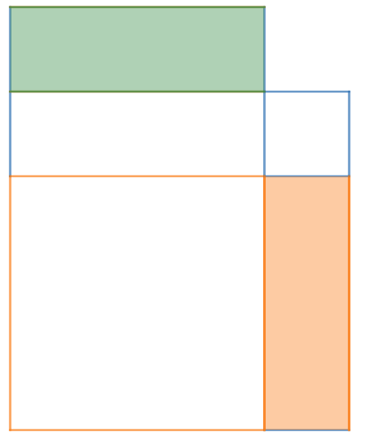
I
H

$$1$$
$$1$$
K
J
$$1$$
$$1$$
$$x$$
G
$$1$$
$$1$$
C
D
E
$$1$$
$$x$$

$$x$$
$$x$$
$$x$$

$$1$$
$$x$$
F
A
B

The area of rectangle $ABIH$ needs to be subtracted from the area of the square $AGKF$. The area of the shaded green rectangle is equal to the area of the shaded orange rectangle, so rectangle $ABIH$ can be split up into two parts, rectangle $ABJG$, which is inside the square$AGKF$, and the green rectangle. The green rectangle can be placed inside the square $AGKF$, in the place of the orange rectangle. So the above diagram becomes

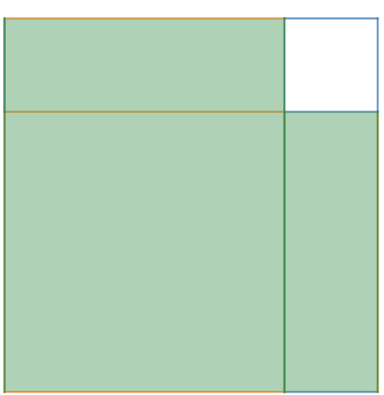

Where the green area is equal to the area of the rectangle $ABIH$. Subtracting this area from the larger square, we get a square with a side length of 1, therefore its area is 1

For part 3

$$3×3-1×1=8$$

$$8×8-6×6=28$$

$$7×7-5×5=24$$

If you take two numbers with a difference of 2 and subtract the square of the smaller one from the square of the bigger one, the result is four times the mean of the two numbers. Represented algebraically, this is

$${\left(x+2\right)}^{2}-x^{2}$$

By the difference of two squares,

$$(x+2+x)(x+2-x)$$

Which simplifies to

$$(2x+2)(2)$$

Factorising,

$$2(x+1)(2)$$

Simplifying,

$$4(x+1)$$

The diagram for the above pattern is

$$2$$
$$x$$
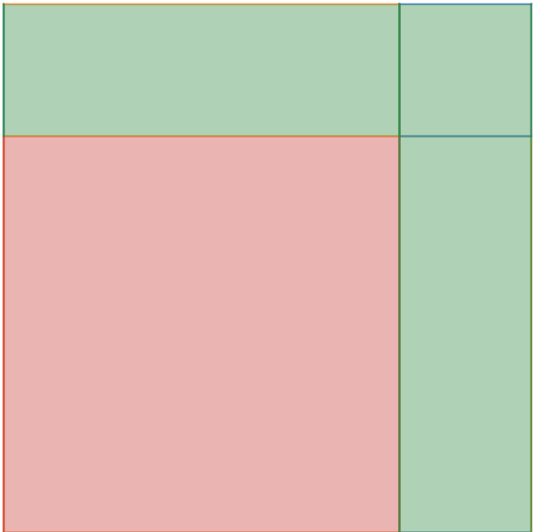
$$x$$
$$2$$
$$2$$
$$2$$
$$2$$
$$2$$
$$x$$
$$x$$
$$x$$
$$x$$
The red square is being subtracted from the larger square, which leaves behind the green area, which can be arranged like this

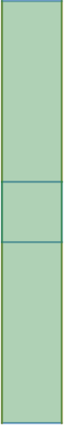
$$x$$
$$2$$
$$x$$
$$2$$

This is a rectangle with dimensions of $2$ and $x+2+x=2x+2=2(x+1)$. Therefore the area of the rectangle is

$$2*2\left(x+1\right)$$

Which simplifies to

$$4(x+1)$$

For part 5

$$3×5+1=16=4^{2}$$

$$5×7+1=36=6^{2}$$
$$7×9+1=64=8^{2}$$

If you add one to the product of two numbers that differ by 2, the result will be the square of the mean of the two numbers. Represented algebraically, this is

$$x\left(x+2\right)+1$$

Expanding the brackets,

$$x^{2}+2x+1$$

Factorising,

$${\left(x+1\right)}^{2}$$

The diagram for the above pattern is

$$1$$
$$1$$
$$1$$
$$1$$
$$1$$
$$x$$
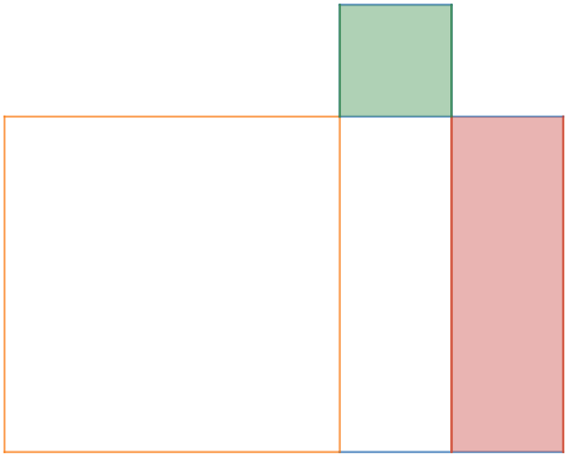
$$1$$
$$x$$
$$x$$
$$1$$
$$x$$
$$x$$
$$x$$
The diagram can be rearranged like this

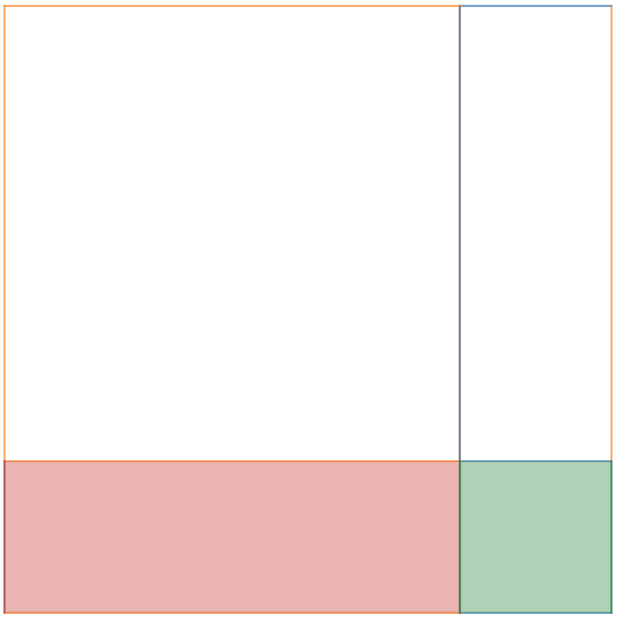
$$1$$
$$x$$
$$x$$
$$x$$
$$1$$
$$x$$
$$1$$
$$1$$
And this is a square with a side length of $x+1$, therefore its area is ${\left(x+1\right)}^{2}$

For part 6

$$1×2+2×3=8=2(2^{2})$$

$$2×3+3×4=18=2\left(3^{2}\right)$$

$$3×4+4×5=32=2(4^{2})$$

The sum of the products of the smallest two of the consecutive numbers and the products of the greatest two of the consecutive numbers is twice the square of the middle number. Represented algebraically, this is

$$x\left(x+1\right)+(x+1)(x+2)$$

Factorising,

$$(x+1)(x+x+2)$$

Simplifying,

$$(x+1)(2x+2)$$

Factorising,

$$2(x+1)(x+1)$$

Simplifying,

$$2{\left(x+1\right)}^{2}$$

The diagram for the above pattern is

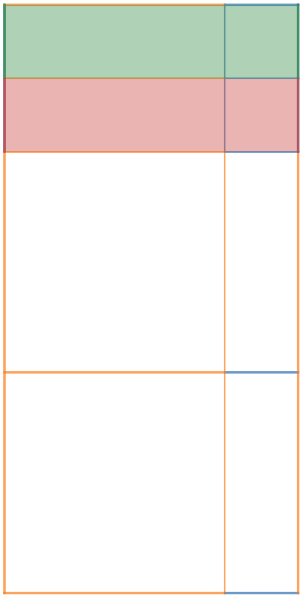
$$1$$
$$1$$
$$x$$
$$x$$
$$1$$
$$1$$
$$1$$
$$1$$
$$1$$
$$1$$
$$1$$
$$x$$
$$x$$
$$1$$
$$1$$
$$x$$
$$x$$
$$x$$
$$x$$
$$x$$
$$x$$
$$x$$

This is a rectangle with width $x+1$ and height $x+x+1+1=2x+2=2(x+1)$. Therefore, the area of the rectangle is

$$2(x+1)(x+1)$$

Which simplifies to

$$2{\left(x+1\right)}^{2}$$

