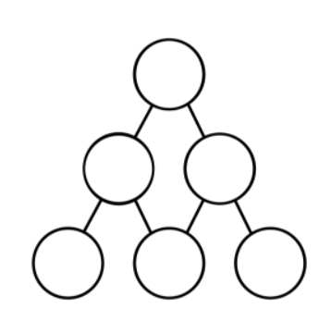
5 cannot be at the top:
If 5 was placed at the top, then the only possible next two numbers would be 1&6. Since the range of the numbers only goes up to 6 it is not possible to have a difference of 6 between the two numbers below therefore it is an impossible combination.
4 cannot be at the top:
If 4 was placed on the top then there would be two possible combinations of numbers to go on the second row. It could be either 2&6 or 1&5.
2&6 would not be possible because 6 has to be on the bottom row since there are not any numbers between the range of 1 and 6 that can have a difference of 6.
1&5 would also not be possible because the numbers below would have to use 1 and that is not possible because you can only use each number once.
6 must be at the bottom
The number 6 must be on the bottom row because the range of numbers provided goes up to 6 therefore there would be no combination of numbers that has a difference of 6 within that range.

