Here are some more triangles drawn in the same way.
Which one looks as though it has the largest area? Which actually has the largest area?
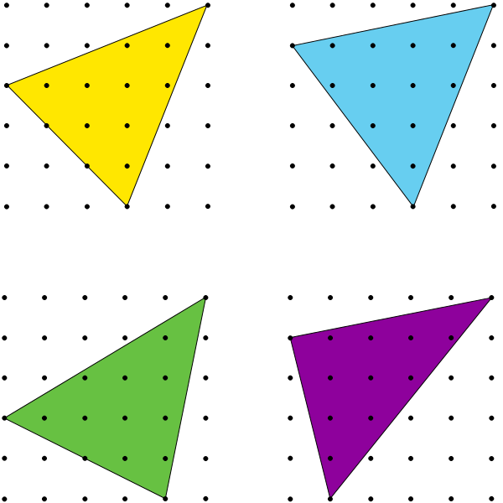

You subtract the empty triangles from the large square, which is 5*5= 25
Yellow: you get the area of the blue triangles, and subtract it from the whole.
25- $\left(\frac{3×3}{2}\right)$- $\left(\frac{2×5}{2}\right)$- $\left(\frac{2×5}{2}\right)$
= 25- 4.5- 5- 5
= 10.5
(The same goes for the other triangles)

Blue: 25- $\left(\frac{3×4}{2}\right)$- $\left(\frac{2×4}{2}\right)$- $\left(\frac{1×5}{2}\right)$
= 25- 6- 4- 2.5
= 12.5

Purple:

25- $\left(\frac{1×4}{2}\right)$- $\left(\frac{5×4}{2}\right)$- $\left(\frac{1×5}{2}\right)$
= 25- 2- 10 -2.5
= 10.5

Green:
25- $\left(\frac{2×4}{2}\right)$ - $\left(\frac{1×5}{2}\right)$- $\left(\frac{3×5}{2}\right)$
=25- 4- 2.5- 7.5
=11

Answer: the blue triangle has the largest area.

The every possibility that can be produced with a vertex at (5,5), a vertex on the left hand side and a vertex on the bottom side of square, we first need to multiply 6 by 6. 6*6= 36. Because for every vertex on the left side there can be 6 different triangles with one more vertex on the bottom line, and there are 6 vertex on the left side. However, we would need to minus the vertex on the left side and bottom side both being at (0,0) because then it wouldn’t make a triangle.

For the smallest area such a triangle can have, we would need to minimize the length between the vertex on the left side and the bottom side of the square. So except for both vertex on (0,0) which would make a line not a triangle, the smallest triangle is:
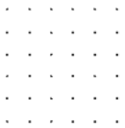or which is: 25- $\left(\frac{4×5}{2}\right)$- $\left(\frac{5×5}{2}\right)$
= 25- 10- 12.5
= 2.5
For the largest area such a triangle can have, we would need to maximize the length between the vertex on the left side of the square and vertex on the right side of the square. So it’s

Or

Which is: 25- $\left(\frac{5*5}{2}\right)$= 25- 12.5
=12.5

All the triangles are possible to make between 12.5cm^2~ 2.5cm^2

The general expression is 25- $\frac{\left[5× \left(5-x\right)\right]+ \left[5× \left(5-y\right)\right]+xy}{2}$I first took an example of 12.5cm^2 with the vertex followed: (5,5), (x,0), (0,y) and tried to come up with the area 12.5

The equation for 6*6 grid, 7*7 grid and 100*100* all remains the same except you have to replaced the 5 with the grid number and 25 with the square of the number of your grid.

