Cryptarithms Solution
By MJ Hoang, The Bourne Academy, Hadow Road, Bournemouth
I started by thinking about how many digits were being added. So for the first one, A had to be a single digit number greater than or equal to 4 so that 3 lots of it would equal a 2 digit number (e.g. 3+3+3=9 which only has one digit, whereas 4+4+4=12 which has two digits). Questions 3-5 all followed a similar pattern with a 2-digit number close to 100 (so in the 90’s) that when added to a single digit number pushes the answer into 3-digits. From then on, I just kept thinking about how many digits were being added and found each time there was a key letter I could work out each time e.g. on question 7, B had to = 1 as you cannot add two 2-digit numbers together and get a number above 198. For question 13, just looking at the units column if A + B + A = B, then A must be equal to 5 as otherwise you would have more than a B in the answer (5+5 = 10, so no units).
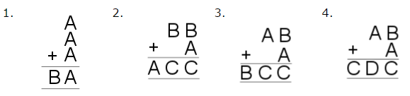
A = 5 B = 1 A = 1, B = 9, C = 0 A = 9, B = 1, C = 0 A = 9, B = 2, C = 1, D = 0
5 + 5 + 5 = 15 99 + 1 = 100 91 + 9 = 100 92 + 9 = 101
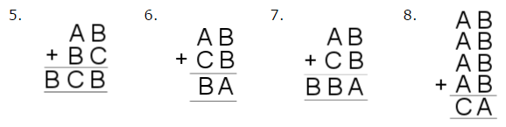
A = 9, B = 1, C = 0 A = 4, B = 7, C = 2 A=2, B=1, C=9 A=2 B=3 C=9
91 + 10 = 101 47 + 27 = 74 21 + 91 = 112 23+23+23+23=92

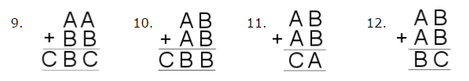
A=9 B=2 C=1 A=5 B=0 C=1 A=2 B=6 C=5 A=2 B=5 C=0 99+22 = 121 50+50= 100 26+26= 52 25+25= 50
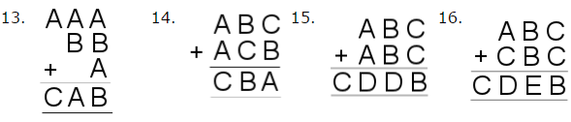
A=5 B=9 C=6 A=4 B=5 C=9 A=7 B=2 C=1 D=4 A=9 B=2 C=1 D=0 E=4
555+99+5=659 459+495=954 721+721=1442 921+121=1042

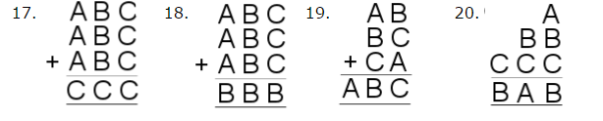
A=1 B=8 C=5 A=1 B=4 C=8 A=1 B=9 C=8 A=4 B=7 C=6
185+185+185=555 148+148+148=444 19+98+18=198 4+77+666=747

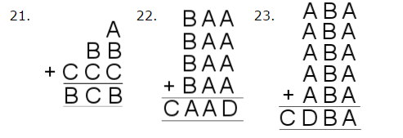
A=2 B=9 C=8 A=9 B=4 C=1 D=6 A=5 B=7 C=2 D=8
2+99+888=989 499+499+499+499=1996 575+575+575+575+575=2875

