Myself, Shubhangee, had worked in Ganit Kreeda, Vicharvatika,india with 15 kids, Sowjanya, Avyukt Aggrawal, Adhrit, Achyuth, Ridhit, Niveditha, Pranit, Taran, Avyukt Aswin, Rudransh, Abhiram, Nishika, Vidyut, Vishnu and Ruhaan; of 4th to 6th grades on Add to 200 problem.
We enjoyed working on it collaboratively.
- Kids worked in small groups and all of them got different answers and their approach was also different. Initially kids used trial and improvement method to find several solutions and then they narrowed down to 200 by changing few numbers.

Here are few answers they got initially.
- Pranit tried to find out pairs of 100, such that units place of one number is same as tens place of second number such as 81-19; 63-37.
8 | 1
1 | 9

6 | 3
3 | 7
Ridhit and Niveditha along with Pranit took it ahead in a systematic way.
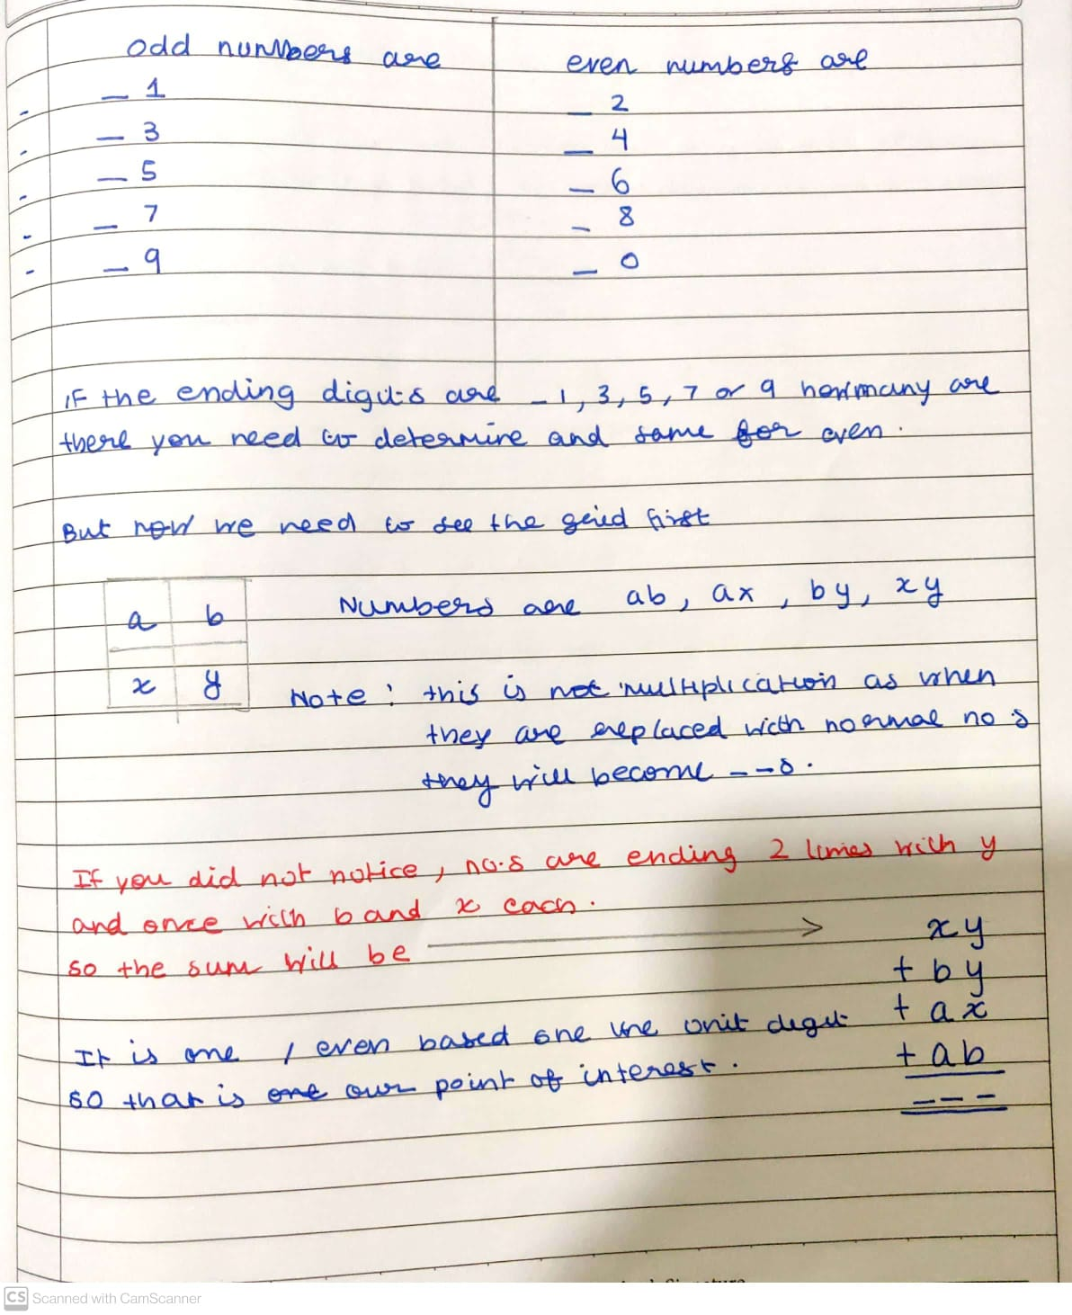
Niveditha took it ahead and explained her journey in the following 11 pictures.
She explained when sum will be even or odd using this picture.

She noticed that units place digits are y,y,x and b. Whatever is y, as y is used twice, 2y is always even. So the sum is even or odd if (x+b) is even or odd respectively.
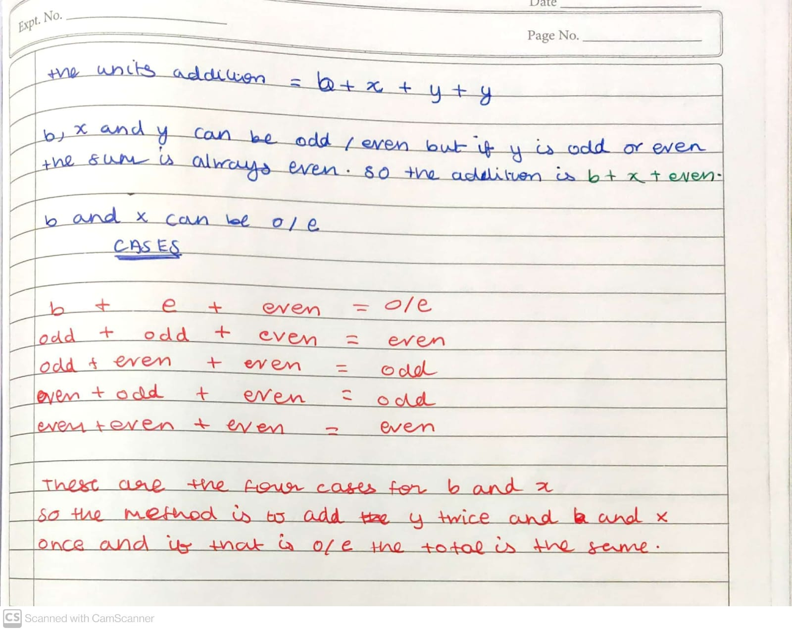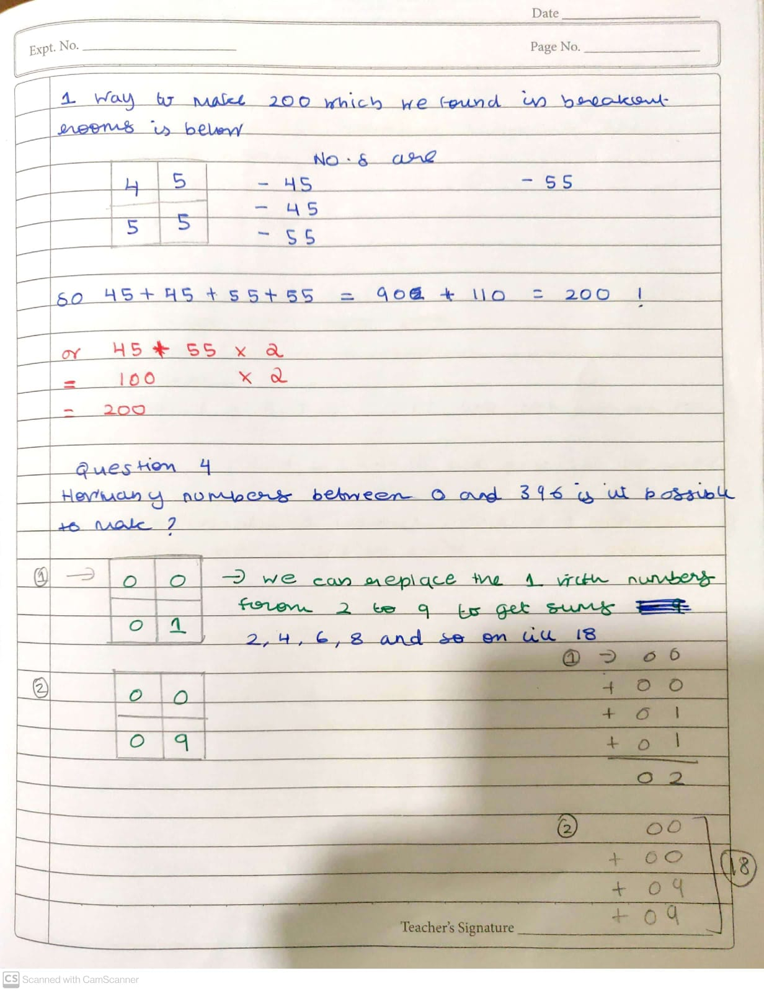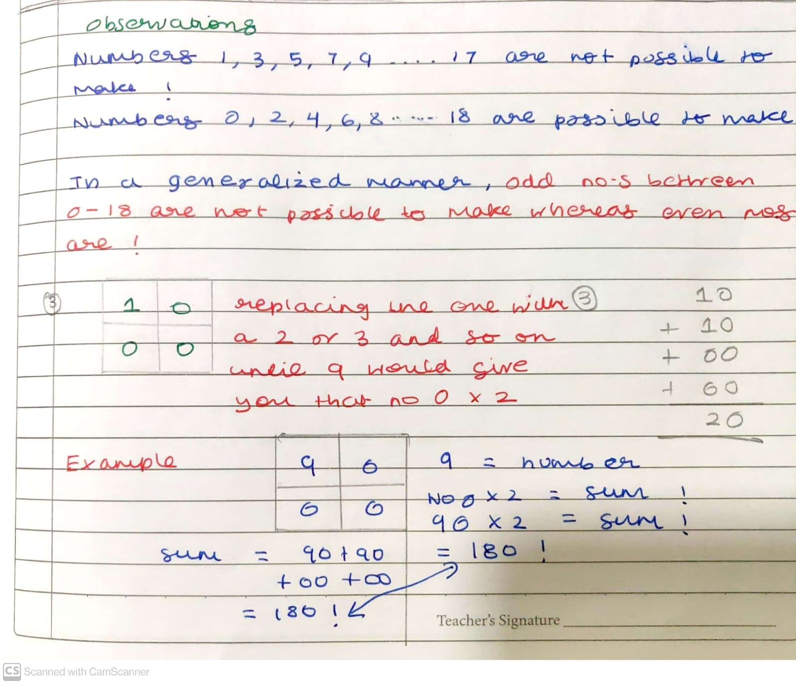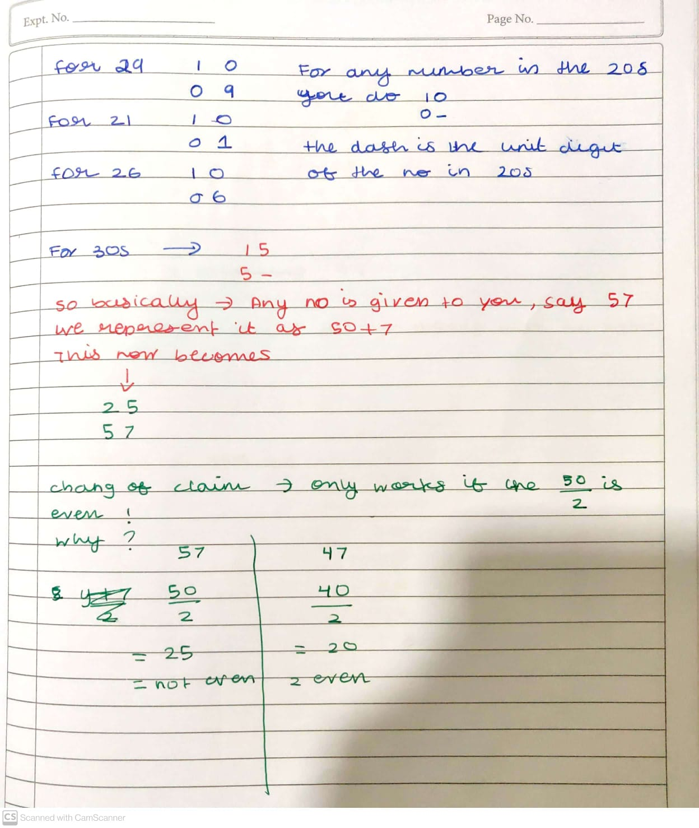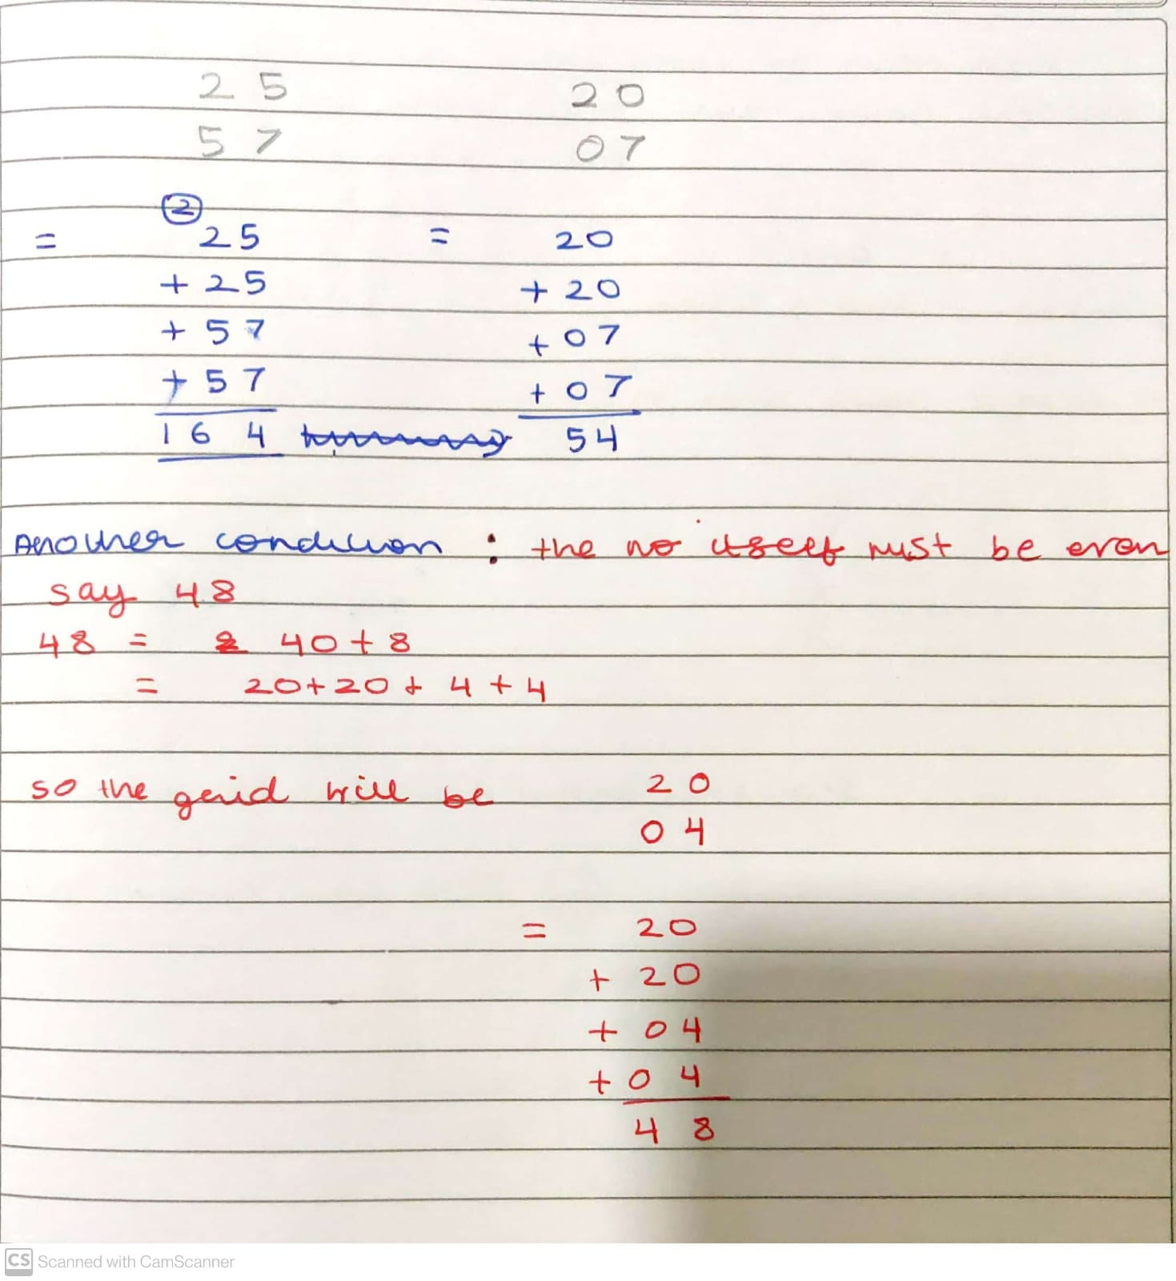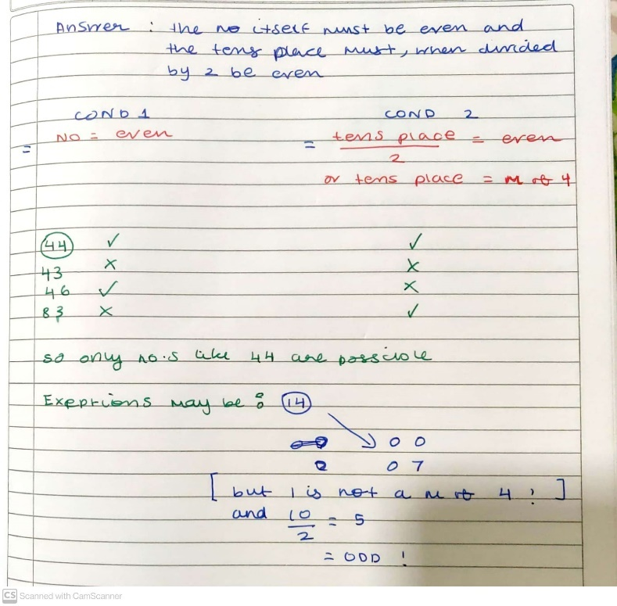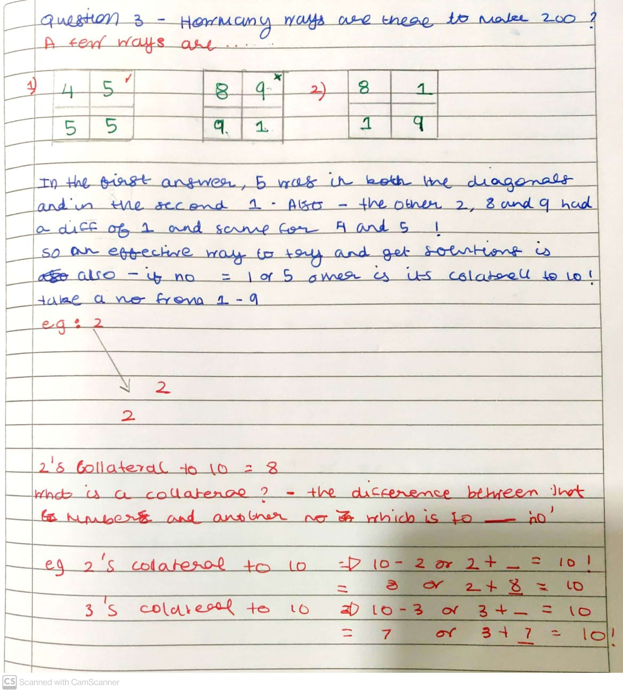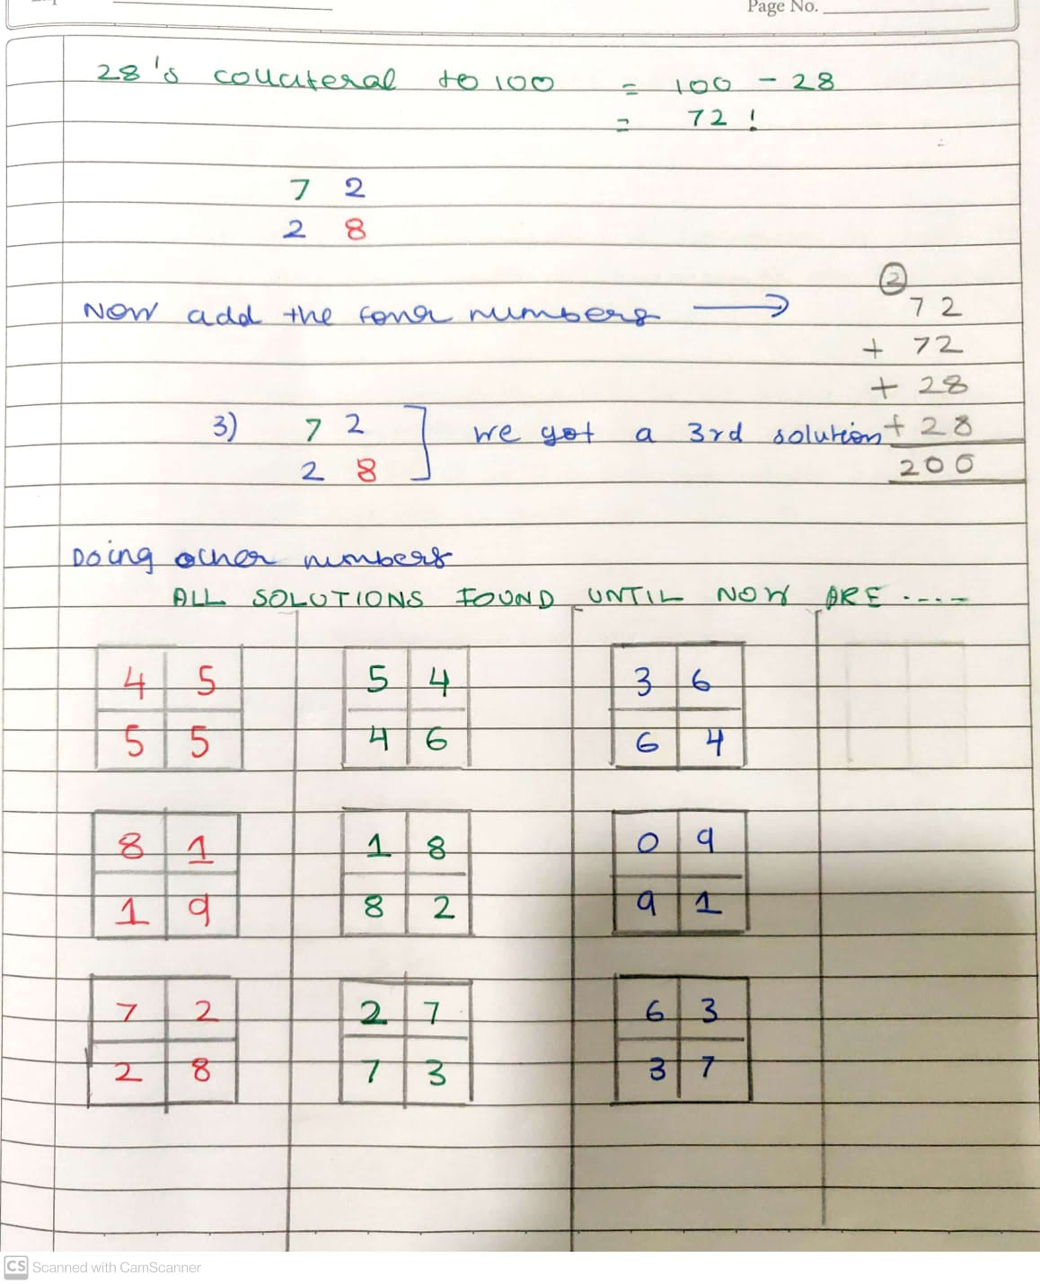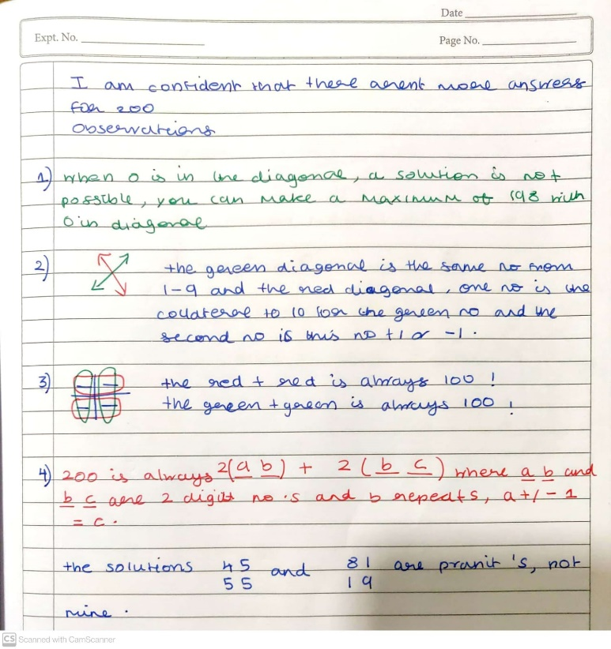

- While experimenting with different examples, Avyukt noticed that by increasing bottom rightmost digit by 1 the sum is increased by 2. The reason was explained by Rudransh as follows.

5 | 3
5 | 6
Digit 6 is at unit’s place in both vertical and horizontal addition. So, it changes sum by 2.
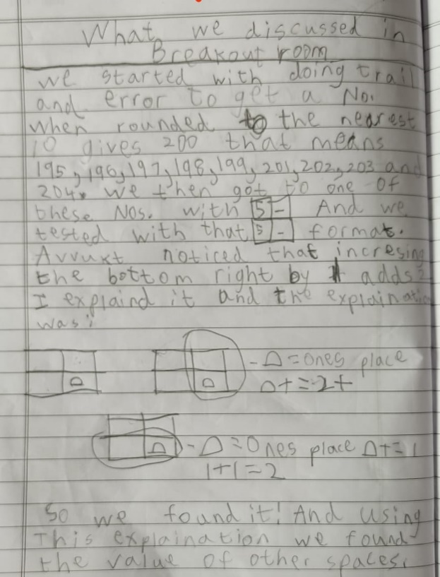

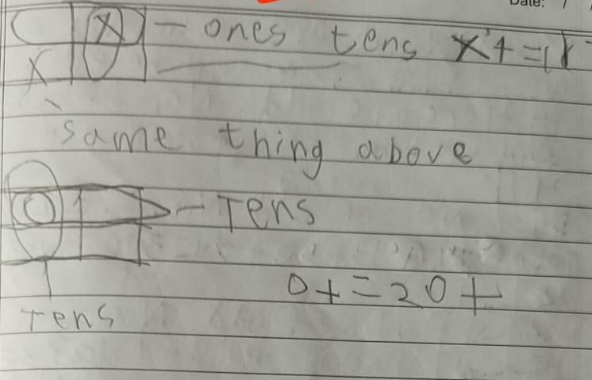 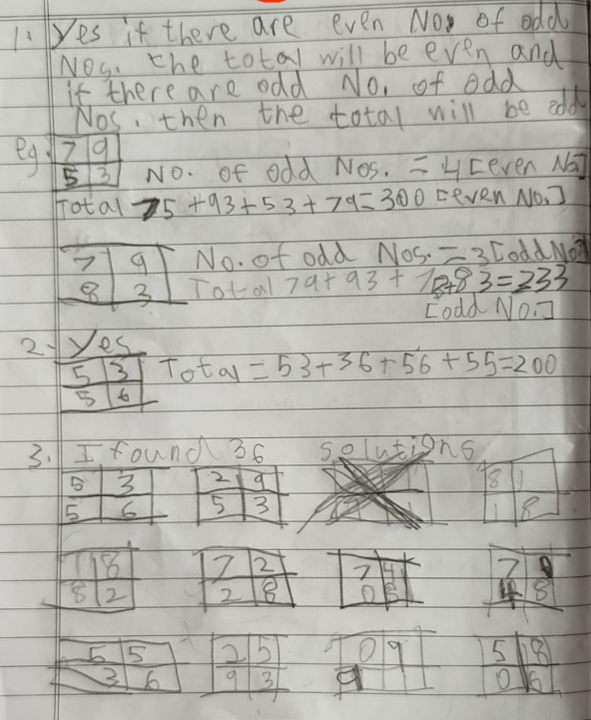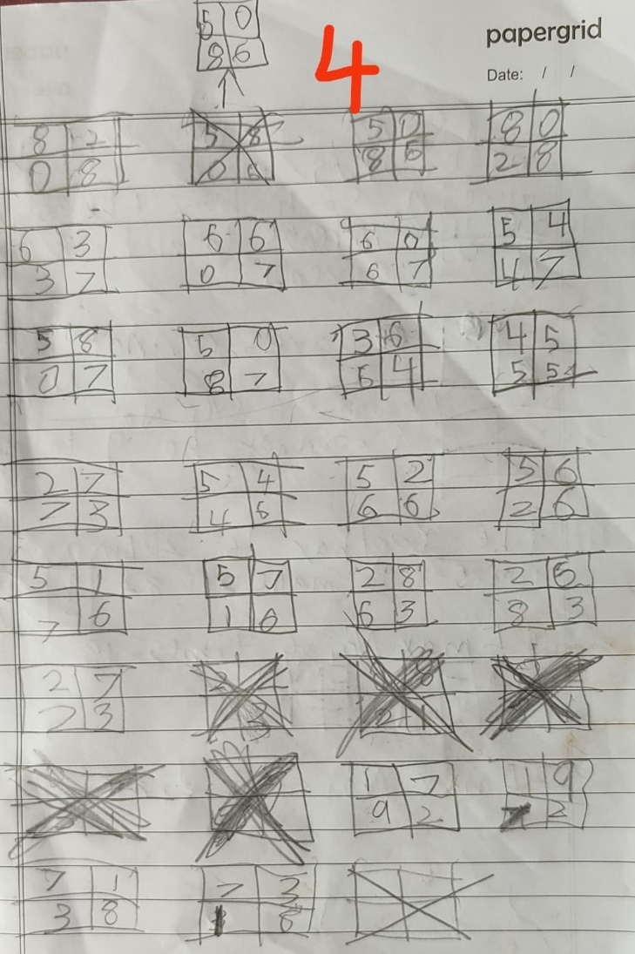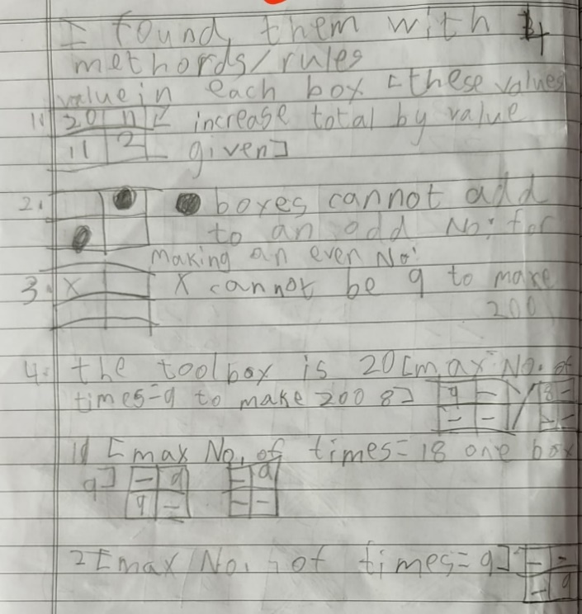i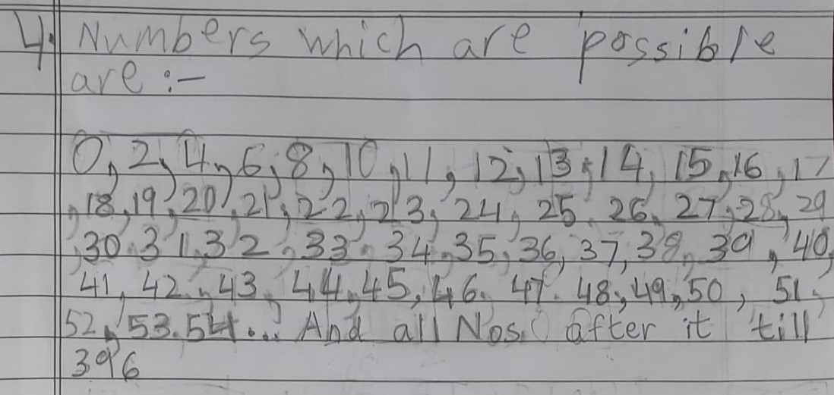

- Rudransh’ reason was explained using algebra.
a b
c d

20a + 11(b + c) + 2d = 200
It is clear that :
a cannot be 9, as 180 + 20 is 200 and d cannot be 10 and 180 + 11 or 180 + 22 will not add to 200.
a can take values from 1 to 8.
when a = 8, (b + c) can only be 2 and d = 9
when a = 7, (b + c) can only be 4 and d = 8
and so on...

- All the kids from the Ganit Kreeda worked collaboratively to find out all possible solutions using above strategy and algebra:
When a=1, (b+c)=16 and d=2 we got 3 solutions.

When a=2, (b+c)=14 and d=3 we got 5 solutions.

When a=3, (b+c)=12 and d=4 we got 7 solutions.

When a=4, (b+c)=10 and d=5 we got 9 solutions.

When a=5, (b+c)=8 and d=6 we got 9 solutions.

When a=6, (b+c)=6 and d=7 we got 7 solutions.

When a=7, (b+c)=4 and d=8 we got 5 solutions.

When a=8, (b+c)=2 and d=9 we got 3 solutions.

Total Solutions are: 3+5+7+9+9+7+5+3= 48
Q. Which numbers between 0 and 396 is it possible to make?
It is not possible to make 1,3,5,7 and 9…single digit odd numbers.
All other numbers are possible.
0,2,4,6,8,10,12,14,16,18 are possible by assigning d = 0,1,2…..9.
11,13,15,17,19,21…29 are possible by assigning (b+c)=11 and d=0,1,2,3….9
20,22,..,38 are possible by assigning a=1 and d=0,1,2,3….9
31,33,..,49 are possible by assigning a=1,(b+c)=11 and d=0,1,2,3….9
And so on.

