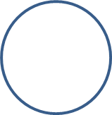
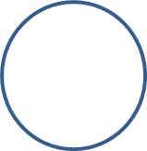
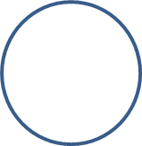
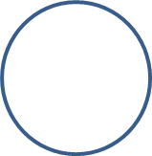
The lower and upper bound is 13 so there is nothing between 13 and 13 so there is a solution for everything between the lower and upper bound because the only ring total is 13 and that is the number between 13 and 13.
The lower and upper bound is 13 because all the circles add to 13. If you get all the number bonds to a number and all the 3- number bonds to the same number, you can use the normal bonds to the number and work out all the possible outside circles and then, with the number in the overlaps, you can use the 3 number bonds to work out the other overlap, and what is in the 2 circles that are closer to the middle. Then with that, you can work out what is in the middle circle.
I know that the overlaps add up to a multiple of 5 because in the answer, they add up to twenty and that is a multiple of 5.
As you can see, there is only 1 solution possible for this problem.
[Type a quote from the document or the summary of an interesting point. You can position the text box anywhere in the document. Use the Drawing Tools tab to change the formatting of the pull quote text box.]
[Type a quote from the document or the summary of an interesting point. You can position the text box anywhere in the document. Use the Drawing Tools tab to change the formatting of the pull quote text box.]
6
7
2
5
8
3
1
4
9
Doesn’t work
Doesn’t work
Works
3
2
7
6
4
5
8
9
1
7
6
5
2
4
3
8
1
9

