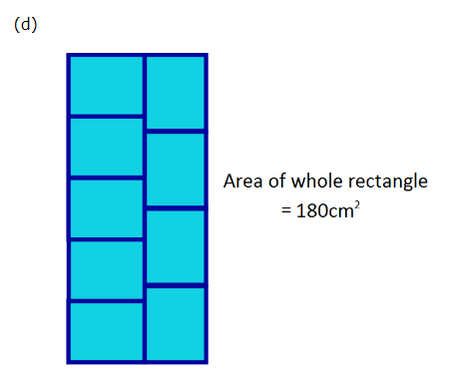
So I first divided 180 (the total area) by 9 (the total amount of squares.) This gives 20, so the area of the smaller squares are 20cm². To work out the perimeter of the squares you need to find the correct lengths of each side, and to do that you need to use trial and error. Firstly I tried to use 10 and 2, which didn’t work at all, so then I tried 5 and 4, therefore 9 (top side of the diagram (4+5)) and 20 (side of the diagram (5x4)) and 9x20=180 so 4+4+5+5 is equal to the perimeter of the small rectangle, so the answer is 18cm.

