Perimeter Challenge Answers!
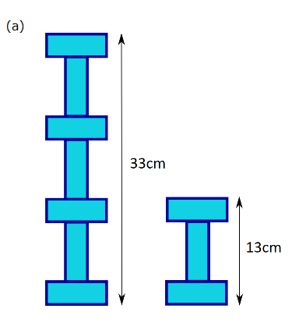
In the figure you can see that there are 2 of the smaller figure (the 13cm figure) and one long rectangle. Using that we can conclude that the 2 small figures equal 26cm ,so we know we need 7cm more to get the right perimeter. So the long rectangle must be 7cm. Now we go back to the small figure knowing that the long side of the rectangle is 7cm the small sides must be 3. (3+3+7=13) Now you can conclude that 3+3 (the small sides) plus 7+7 (the long side) = 14+6 = 20, so the perimeter of question A is 20cm

