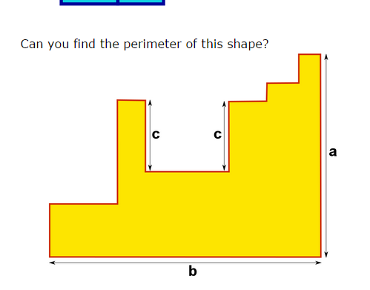
1’s add to a
2’s add to b
Add 2c,a,b
Answer is 2c+2b+2a or 2(a+b+c)

1
2
1
2
2
2
1
1
2
2

