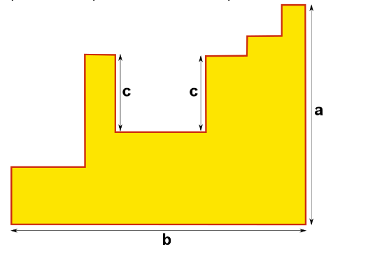
The lengths so far are A, B and 2C
The horizontal lines that are parallel to B are the same length added together. The vertical lines parallel to A are the same length excluding the two C’s. The two C’s are excluded from A because their length has already been included in another vertical line. So now there are lengths A, A, B, B, C and C. Added up the perimeter is 2A+2B+2C.

