
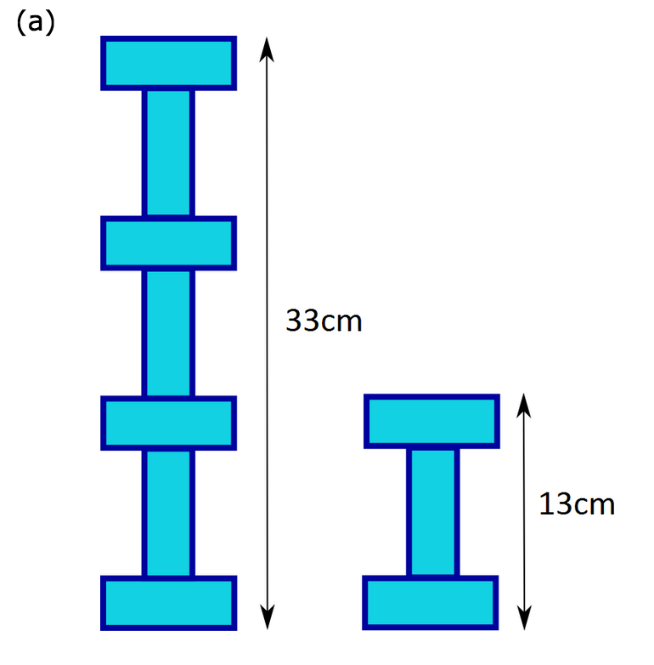
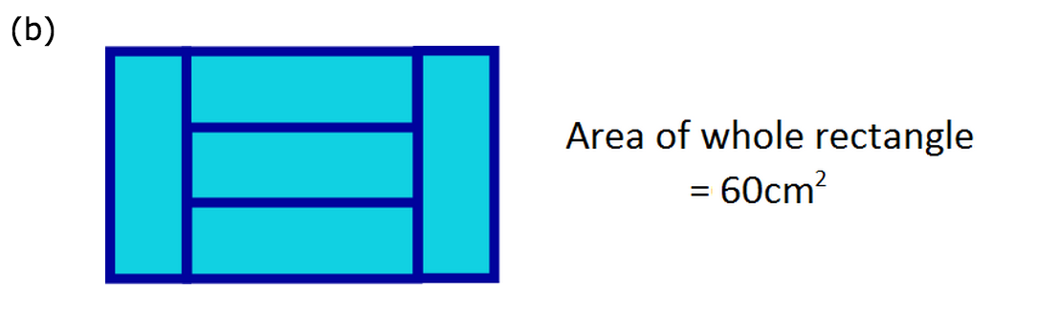
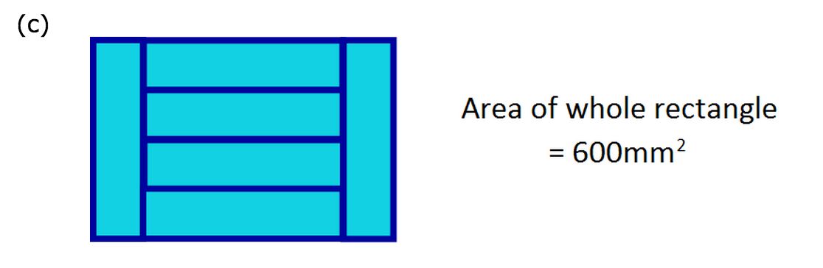
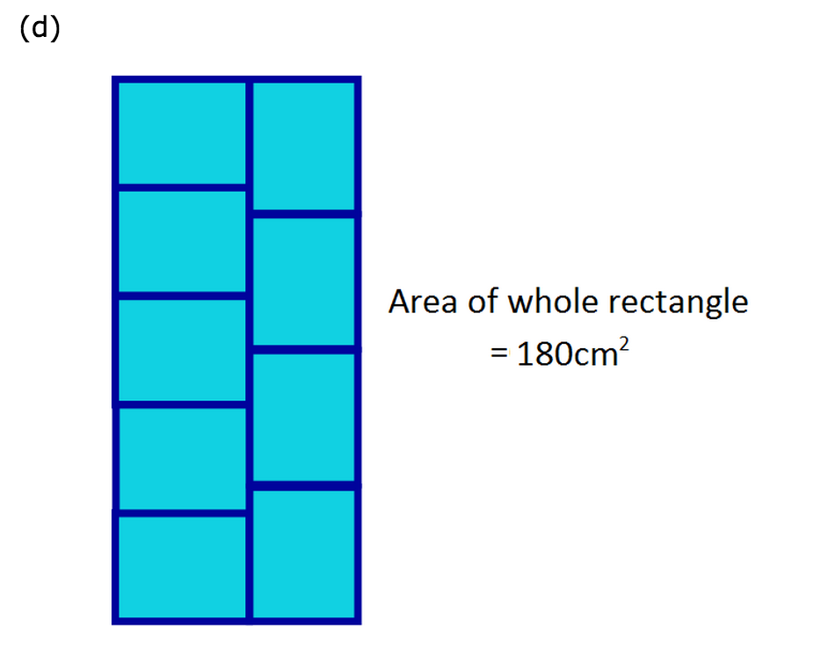
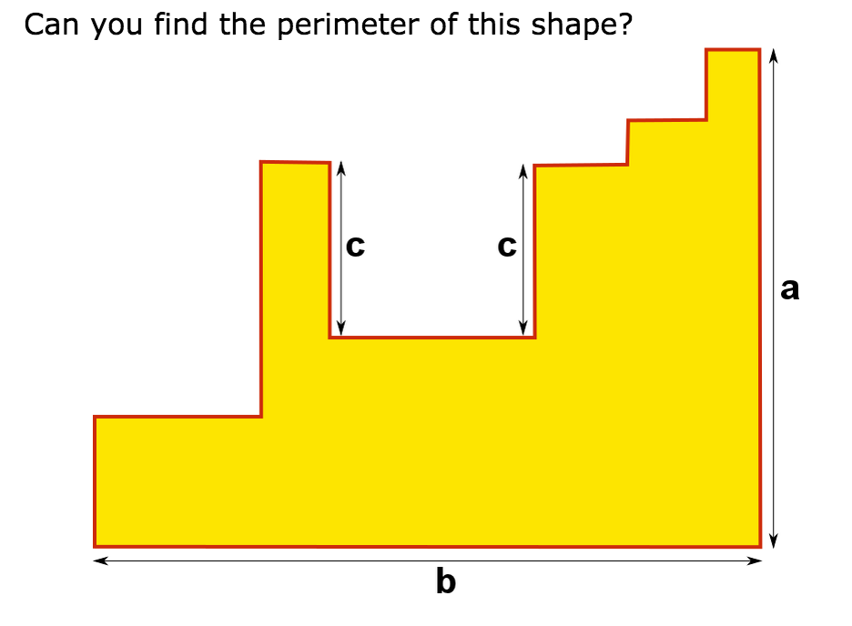
$$4x+3y=33$$

$$4x+2y=26$$

$$2x+y=13$$

$$4x+3y=33$$

With these two equations, we can create a simultaneous equation like this:
$$4x+3y=33$$

In equation form, it would be:
The bigger diagram has 4 horizontally stacked rectangles and 3 vertically stacked rectangles. The height is given: 33cm
$$2x+y=13$$

So, we can say that
Lets say that the sides of the rectangles are $x$ and $y$.
The smaller diagram shows 3 rectangles stacked up, 2 horizontally and one vertically. The height is given: 13cm
$$x$$
$$y$$
Don’t forget the units!
$$2\left(3\right)+2\left(7\right)=P$$
$$6+14=P$$
$$20cm=P$$
Doing the same thing as the previous question, make $x$ the width and $y$ the length
Equation for finding the perimeter would be $2x+2y$. We need to plug in the numbers to find the perimeter of the rectangle.
$$2x+7=13$$
$$2x=6$$
$$x=3$$
Since we have $y$, we can find $x$, using the equation $2x+y=13$
$$y=7$$

$$4x+3y=33$$

$$4x+2y=26$$

We then, have to solve it.

Don’t forget the units!
$$2\left(2\right)+2\left(6\right)=P$$
$$4+12=P$$
$$16cm=P$$
We plug $x$ and $y$ in the perimeter equation from the question before.
$$y=3(2)$$
$$y=6$$

We have $x,$and we have to find $y$. We have already found out what y is in the form of $x$. Let’s plug the $x$ in the equation.
$$3x\left(x\right)=12$$
$$3x^{2}=12$$
$${ x}^{2}=4$$
$$x=2$$
We know the area of one rectangle and we know that three widths is one length. We now need to put it together in one equation, and solve it.
$$y=3x$$

If you look at the diagram, three widths make up one length of the rectangle. We can put it into an equation like this:
$$xy=A$$

So the area of one rectangle is 12 square centimetres
To find the area of a rectangle, we have to multiply the width by length.
$$60÷5=12$$

The area of 5 rectangles is 60 square centimetres. So, we need to divide 60 by 5, to get the area of one rectangle.
Don’t forget the units!
$$2\left(5\right)+2\left(20\right)=P$$
$$10+40=P$$
$$50mm=P$$
And find the perimeter…
$$y=4(5)$$
$$y=20$$
And plug in the $x$ to find the $y$…
$$4x\left(x\right)=100$$
$$4x^{2}=100$$
$${ x}^{2}=25$$
$$x=5$$

And now we need to plug in what we’ve got.
The diagram shows that four widths is one length.
$$xy=A$$

Let’s remember the area formula.
$$600÷6=100$$

This question is similar to the problem before. We have to adapt this question.
There are 6 rectangles in the diagram, and their area is 600 square millimetres. Like the question before, we need to divide 600 by 6 to get an area for one rectangle.
$$y=4x$$

$$x\left(\frac{4x}{5}\right)=20$$
Now, we have to put the equations all together.
$$y=\frac{4x}{5}$$
To create an equation with one variable, we must make either $y$ or $x$ in a subject. For instance, lets make $y$ in the form of $x$.
$$A=180÷9$$
$$A=20$$

There are nine rectangles in total, with areas that total 180 square centimetres. With this information, we can find out the area of one rectangle.
$$5y=4x$$
We can see that 5 rectangles are set horizontally, and their sides add up to 4 rectangles set vertically.
$$x$$
$$y$$
This question is a little bit different. We are given the area of 9 rectangles. So, what can we figure out from this diagram?
And for the last challenge! The diagram gives us three variables to find out the perimeter of its shape. Seems hard, but lets solve this!
$$2\left(5\right)+2\left(4\right)=P$$
$$10+8=P$$
$$18 cm=P$$
Then we apply the Perimeter formula, and then we get the answer!
$$y=\frac{4x}{5}$$
$$y=\frac{4(5)}{5}$$
$$y=4$$
Since we know what $x$ is, we can know find what $y$ is.
$$x\left(\frac{4x}{5}\right)=20$$
$$x\left(4x\right)=100$$
$$4x^{2}=100$$
$${ x}^{2}=25$$
$$x=5$$
And, we can see that the topside of the shape adds up to $b$, which makes the equation closer to completion:
$a+2b+\left(others\right)=P$
By this, we can know that the perimeter of this shape is
$a+b+\left(others\right)=P$
If we observe closely, the topside of the shape all add up to $b$
If we look at this shape, there are three variables: $a, b, c$.
We can rotate the diagram to get a clearer view for the next step.
As I drew in the diagram below, the purple lines add up to the total $a$.
So, we know that:
$2a+2b+\left(others\right)=P$
However, there are still more left.
In the diagram above, I have lined the two lengths that have not been included in the equation yet.
The two lengths are two lengths of $c.$
Therefore, the equation ends like this:
$2a+2b+2c=P$

