Same answer
The question gives 5 examples of possible fractions that give the same fraction when subtracting and dividing the same numbers:

3½ - 2 and 3½ / 2
5½ - 4 and 5½ / 4
5 ⅓ - 4 and 5 ⅓ / 4
6 1/7 - 5 and 6 1/7 / 5
7 ⅕ - 6 and 7 ⅕ / 6

We found out that some fractions don’t work but only two of the fractions follow the specifications.

5 ⅓ = 16/3
16/3 - 4 = 16/3 - 12/3 = 4/3
16/3 / 4 = 4/3
And
7 ⅕ = 36/5
36/5 - 6 = 36/5 - 30/5 = 6/5 = 1 ⅕
36/5 / 6 = 36/30 = 6/5 = 1 ⅕

We found that for the 2 numbers that give the same answer, if you change the mixed fractions to improper fractions, the numerator is a square number and the square root of the numerator is the number that you are subtracting or dividing:

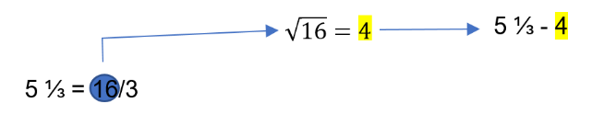

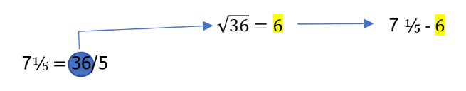

Furthermore, when the fraction is still in the proper form, the whole number is 2 larger than the denominator and the numerator is always 1. With this, we found out that there is an infinite amount of fraction that can be both divided and subtracted and ending with the same result as there is infinite square numbers. The formula for this is n+1 * 1/n-1 subtract or divide by n where n is an integer that is larger than 3 (n>3)

