Note: If it is italics, it doesn’t need to be included in the explanation. I just wanted to show it was mathematically sound.

Part 1:
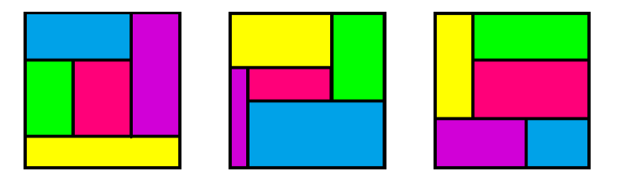
From the first shape you can see that it wouldn't work already as the length of the yellow rectangle is the width of the square, meaning it is 11, and it wouldn't satisfy the conditions. The third shape also wouldn't work as you can see the green and pink triangle has the same width.

Therefore, it means that the third one is the only possible situation. And as you can see from the shape, no sides are the same/take up one whole side of the square.

Part 2:

Originally, I had spent very long doing trial and error (it seemed to be the only way).

Firstly, I tried to narrow it down using the fact that the area was 121 and certain heights had to be odd, even, etc. to make an odd number (121).

From there, I trial and error two things: areas that could make 121, and how those lengths could fit on an 11x11 square.

But this took a long time and I realized I could do it another way.

Just trial and error lengths that could go on an 11x11 square.

However, this also took a long time, so I decided to stop, asked for a hint and try a different way.

First of all, I found out importantly, that of the 3 shapes listed in the previous question, the middle one is the ONLY model you can use for finding rectangles that fit into an 11x11 square and follow the conditions.

This is because, firstly, the maximum number of rectangles you can have making up one side of the square is 2. If you had 4, one rectangle could not make up one whole other side, as the length of its sides cannot exceed 10.

It also cannot have three on one side. As shown by the first rectangle, the only way to get 5 rectangles while still having three one side, is to have one rectangle that has a length of 11. You could then try to shorten the three rectangles, but it would mean you cannot form a rectangle from the remaining space that is left.

You also cannot form the rectangles as shown in the third example; the rectangle on the bottom left (pink in this case), must always be shorter in width than the one on top, or it will create an effect as shown in the third example, meaning it wouldn't satisfy the conditions.

Now that I know this, I also know since one side of the square is 11, that means the rectangles that form it are either of one of these five widths:

1,10
2,9
3,8
4,7
5,6

And since there are five of them, the remaining one will form the rectangle in the middle!

In addition, I also found out from my previous attempts at trial and error that it doesn't matter which four rectangles on the outside to decide what your lengths could be.

If you turn the shape around, you notice that it has the same pattern either way, meaning it is a reflection of one another and it is unnecessary to check if a certain dimension works on other rectangles.

However, the only exception is the middle rectangle. If you change it changes the whole shape.

Therefore, I would still trial and error, but in a much more limited way. I would now just trial and error with the middle rectangle being one of the five dimensions listed above.

E.g

For 5,6

To make a height of 6, you could do 10-4

Therefore:

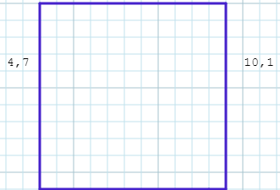

(I didn’t draw it precisely because I needed to check in the first place if the numbers even worked first)

You are left with the lengths 5,6 and 2,9. Unfortunately, none of them can subtract to make a width of 5.

You could do 9-3, but again, it doesn’t work.

You could do 8-3, but it doesn’t work because they both make up one side of a rectangle

You could do 7-1, but you would be still left with the same dimensions as before when you did 10-4, so it wouldn’t work.

I also always picked the highest number to be the width. This is because it meant the higher the number, the less calculations I would have to do.

E.g, for some dimensions, like 1,10 I could immediately rule it out as no number forms 10, etc.

And because of the reflection rule I explained earlier, if using 6 as the height doesn’t work, you don’t need to check if 5 works for that.

After doing this, I discovered that only this solution works!
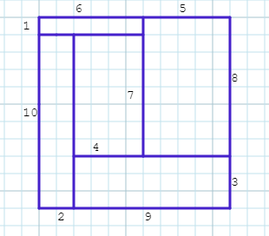
(You could’ve made the length of the bottom 9,2 (in that order), and then the top 5,6 to make a width of 4, but then the length of the bottom left rectangle would exceed the length of the top rectangle so it wouldn’t work)

Tips:
- Always try to narrow down your trial-and-error options
- If one way doesn’t work, and you’ve been doing it for a long time, and you keep pushing, it’s probably the wrong way, so just stop. Do it another way or get a hint

