https://nrich.maths.org/11134
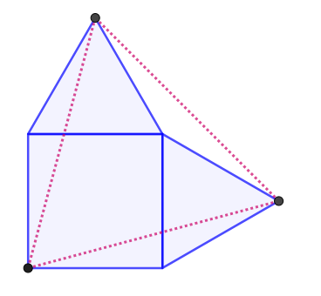
Root(2a^2-2abcos150)
90
150
Root(2a^2-2abcos150)
150
90
Root(2a^2-2abcos150)
a
150
90
Prove the triangle is equilateral
Root(2a^2-2abcos150)= Root(2a^2-2abcos150) so triangle is equalatral

The isocline triangles (both sides must be ‘a’ since one side of the equalatral triangles is equal to the square’s side) forming around the equilateral triangle’s lines can be used in the cosine rule (c^2=a^2+b^2-2abcosx where a and b are ‘a’). In all circumstances ‘x’ can be found to be 150 so it works out into the same result of all sides being equal (in the new triangle) to Root(2a^2-2abcos150)

