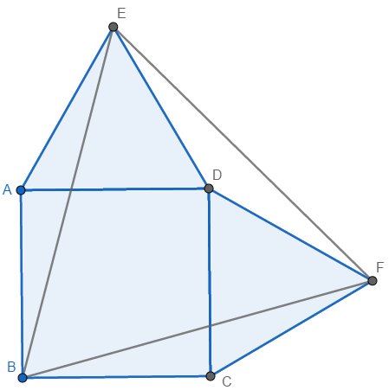
Part A)
Let the vertices of the square be A, B, C, D, and let E and F be the points outside the square such that AED and DFC are equilateral triangles, as shown in the diagram.
Firstly, note that AB = AD, as they are sides of a square, and AD = AE, as they are sides of an equilateral triangle, which means that AB = AD = AE. Importantly, AB = AE. This tells us that triangle ABE is isosceles, with <ABE = <AEB. <BAE = <BAD + <DAE = 90° + 60° = 150°, so <AEB = <ABE = $\frac{(180° - 150°)}{2}$ = 15° as angles in a triangle sum to 180°. Similarly, <BFC = <CBF = 15°.
Now, <ABC = 90° as it is an interior angle of a square, so <EBF = 90° - <ABE - <CBF = 60°.
Additionally, AB = BC, AE = CF and <BAE = <BCF = 150°, which means that triangles ABE and CBF are congruent under SAS, and BE = BF. Hence, triangle BEF is isosceles, with <BEF = <EFB = $\frac{180°-60°}{2}$ = 60°. All three angles of triangle BEF are equal to 60°, so it is equilateral.

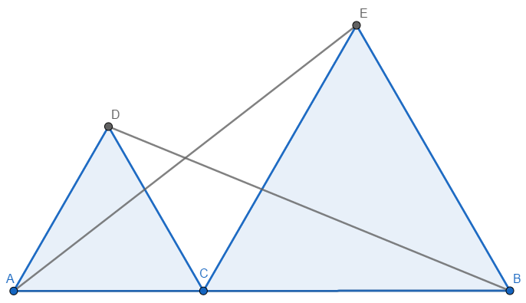
Part B)
Let ADC and CEB be equilateral triangles on the segment AB, as shown in the diagram. Firstly, <DCE = 180° - <ACD - <ECB = 180° - 60° - 60° = 60° as angles on a straight line sum to 180°. Hence, <ACE = <DCB = 60° + 60° = 120°.
AC = DC and CE = CB, as they are sides of the two equilateral triangles, and <ACE = <DCB, so triangles ADC and CEB are congruent under SAS. Therefore, AE $≡$ DB, no matter what size the equilateral triangles are.

