Part A) So to find out the total length of wood needed to make the five main supporting beams for the roof we need to find out the length of one longer beams (labelled A in the diagram below) because if we find out the length of one we can find out the length of the other 3 longer beams (labelled B,C and D) this is because the supporting beams A and B and the side of F and C and D and the side of G create two isosceles triangles therefore the lengths will be the same.
h
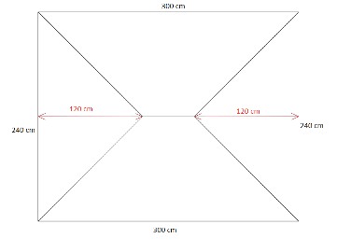
So first to Work out the length of ‘a’ we have to half triangle ABF into 2 triangles then we have to use Pythagoras’ Theorem, this is useful because it helps us find out the length of a=
f
i
e
d
c
b
a
So first we have to square the two lengths:
g
120²=14400
120²=14400
Then add them together and find the square root:
14400+14400=28800
$\sqrt{28800}$ = 169.7056275 A=169.7056275cm*
So now we know the length of A which is equal to B, C and d so now we can times the length of A by 4 :
169.7056275 x 4= 678.8225099cm* – the total length of wood needed for the four main beams
So now we just have to find out the length of e, now to do this we put in two lines from the left point of e right down to the bottom of the roof and then the same from the right point (see diagram below. This will create two triangles equal to triangles ABF and CDG, they are equal because the hypotenuse is the same.
So now because we know that the length of the new line and the base line, forming the new triangle must be 120 this is because the hypotenuse is 169.7056275 and 120²+120²=$\sqrt{28800}$ = 169.7056275
So now we know E= 60 because if we look at side i it equals 300cm so 120+120=240 then 300-240=60!
So now we know what e is we add it to what A,C,B and d equal: 169.7056275 + 60= 738.8225099cm*
Rounded answer=739 cm
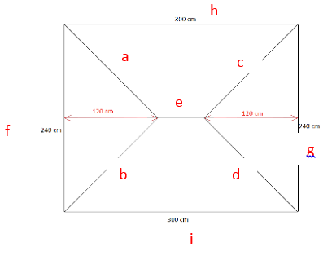 *Scientific Calculator used
Part b) Can you reduce the amount of wood needed by changing the lengths marked in red?
So to do this I first increased the length of e to 120cm, by doing this I decreased the lengths marked in red to 60cm.
Then I used the same method as used for part A but changing the Pythagoras’ Theorem calculations to:
120²=14400
60²=3600= $\sqrt{18000}$ = 134.1640786* the x 4 because there are 4 main supporting beams of the same length = 536.6563146*
Then last adding the value of e which is 120 creating a total of = 656.6563146cm* rounded answer=657 cm
Which is less than the answer to part a.
300 cm
*Scientific Calculator used
240 cm
60 cm
240 cm
60 cm
120 cm
e
300 cm

