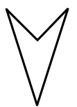
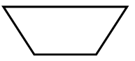
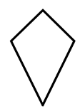
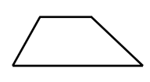
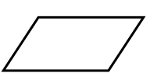
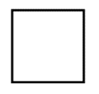
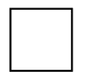
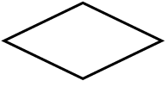
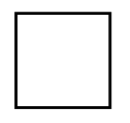

Guess My Quad
YES
NO
NO
NO
NO
NO
NO
NO
YES
YES
YES
YES
YES
YES
Has it got an angle bigger than 180 degrees?
Are all its angles right angles?
Are all its angles the same?
Has it got 2 pairs of equal angles?
Are all its sides equal?
Has it got a pair of parallel sides?
Has it got 2 pairs of parallel sides?

