Solution to ‘Regular Hexagon Loops’

Here are the connections between the inner perimeter, the outer perimeter and the number of tiles:
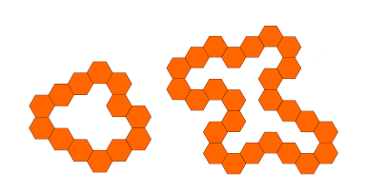
For the values I am about to use, an edge is worth 1.
No. Tiles | Inside P | Outside P
13 | 20 | 32
No. Tiles | Inside P | Outside P
26 | 46 | 58

If we subtract 3 from the no. tiles and multiply it by 2, we get the inside perimeter. If we add 3 to the no. tiles and multiply it by 2, we get the outside perimeter. Here are the equations for that:
IP = 2(No.T – 3)
OP = 2(No.T + 3)

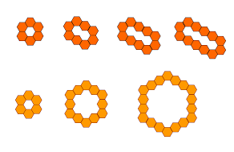
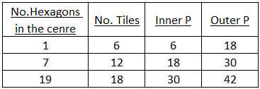
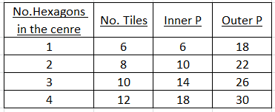
For each shape, there is no relation between the number of hexagons in the centre and the number of tiles. However, the shapes do have a relation; one shape is the shape before it with a contour. If you look at the bottom two values, both have 18 and 30 in common. The next value would have 30 and 42 in common.

For each shape, the contour can be taken off and a new shape is there. The outer perimeter for that is the inner perimeter for the contour. There are a certain number of edges which are touching to others so they do not count in the perimeter. However the difference between the outer perimeter and the inner perimeter is always 12.
The pattern grows and adds on a multiple of 6 tiles each time. The sequence for them is +6, +12, +18...
The pattern grows and adds on 2 tiles each time. This is because the inside gets one more hexagon and two tiles are adjacent to it.

