Growing Suprises:
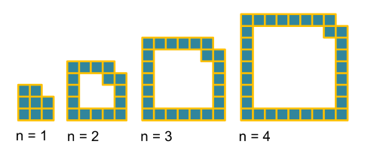
Number of Squares for each pattern:
8 – 16 – 24 – 32
The difference between each pattern is 8. Therefore the formulae for the number of squares in each
pattern is 8n.
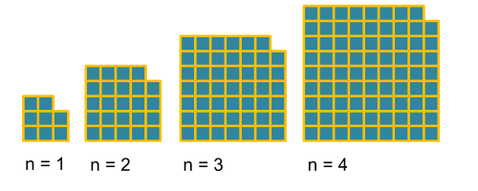
We know the square missing in the shape is always one. Therefore the equation will end with -1. To find the area of the square we need to multiply both sides with each other. To find the equation for the number of sides in each pattern we need to know the difference between each of the,. 3, 5, 7, 9. This gives us an equation of 2n+1. Hence, we need to square the equation, which leads us to (2n+1)². Now, we just need to add -1 and therefore the final solution is (2n+1)²-1. Simplified it is 4n²+4n.

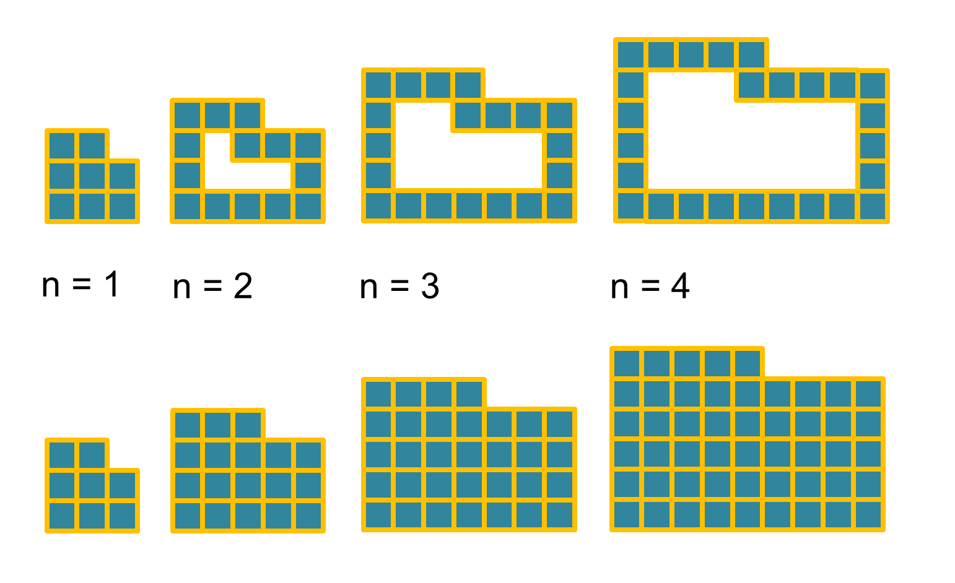
To find the area if a rectangle we need to multiply both sides with each other. In the second sequence we know that the number of squares missing is always equal to n. To find the equation for the second sequence we need to do the following:
Length*Width – n
(n+2) is the width and 2n+1 is the length.
Therefore the equation is (n+2)*(2n+1) – n. Simplified the equation is 2n²+5n+2.
In the first sequence the difference between each pattern is the following:
8 – 14 – 20 – 26
That means the difference is always 6.
Now, we have 6n. In the first pattern then we need to multiply 6*1. This equals 6 but it is supposed to be equal to 8. That’s why we need to add 2 to our equation. This means our equation is: 6n+2.
Observation:
The difference between the first sequence and the second sequence in each pattern is the following:
0 – 8 – 24 – 48
The difference between the third and the fourth sequence in each pattern is the following:
0 – 4 – 12 -24
We can see that the difference between the 1st and the 2nd sequence is always half the difference between the 3rd and the 4th sequence.
By Vladimir Sukhoi and Joseph Izumi

