Which polygons can make rings around a shape which uses only 1 side of each polygon?

In a polygon ring, some particular polygons can form a ring with another polygon inside of it. Not all polygons can do this. The only weird thing about it is that the shape inside the ring has to only use of the exterior sides.

For this example, I will use a ring of pentagons, hexagons, octagons and dodecagons.

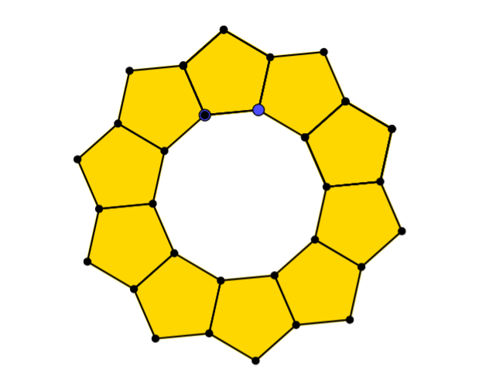
Pentagon (5-gon)

As you can see in this pentagon ring, the inside of the ring has formed a decagon. We can also see that one side of the pentagon makes the decagon (10-gon)

Hexagon (6-gon)
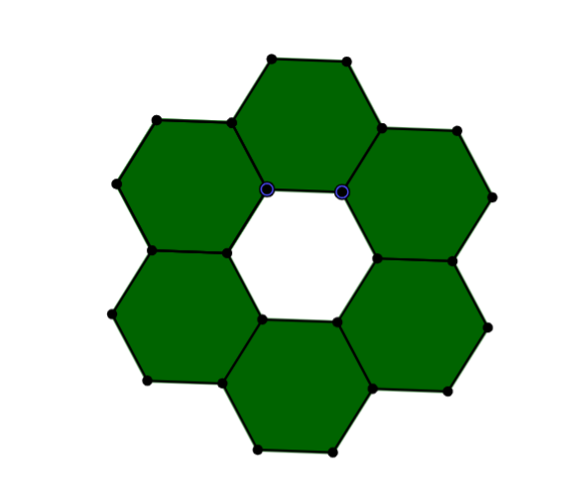
As we can also see in the hexagon ring is that the shape that has formed on the inside of the ring is a hexagon. In this diagram, one side of the shape is used to make the inside shape.

Octagon (8-gon)
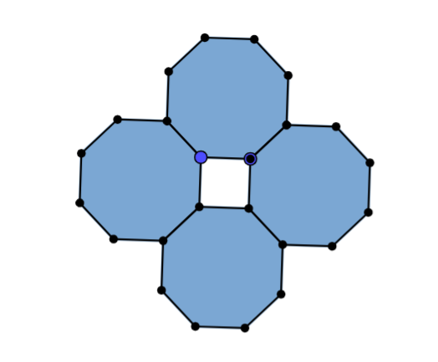
In this octagon, 4 put side by side made a square in the middle. Therefore this fits my investigation on polygon rings.

Dodecagon (12-gon)

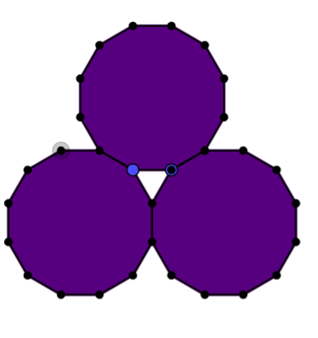
In this dodecagon, 3 of each shape was used to make a polygon in the middle. As we can see the shape is a triangle and only used 1 side of each shape.

