- How many quadratics of the following forms factorize with integer coefficients? Here, b is allowed to be any integer (positive, negative or zero).

- $x^{2}+bx+10$

In order for $x^{2}+bx+10$ to factorize in the form of $(x+y)(x+z)$, $y × z$ must equal to 10.

There are four factor pairs that multiply to give 10:
- $1×10$
- $-1×-10$
- $2×5$
- $-2×-5$

These are the factor pairs in the form of $(x+r)(x+s)$:
- $(x+1)(x+10)$ or $(x+10)(x+1)$
- $(x-1)(x-10)$ or $(x-10)(x-1)$
- $(x+2)(x+5)$ or $(x+5)(x+2)$
- $(x-2)(x-5)$ or$(x-5)(x-2)$

Solve for $b$ (Add the factors together):
- $1x+10x, b=11$
- $-1x-10x, b= -1$1
- $2x+5x, b=7$
- $-2x-5x=-7$

The four values of $b$ that can produce integer factorizations: $±11, ±7$

- $x^{2}+bx+30$

30 has 8 factor pairs: ($1,30), \left(-1, -30\right),\left(2,15\right), \left(-2, -15\right), (3,10), (-3, -10), \left(6,5\right), (-6, -5)$
$$b=±31, ±17, ±13,±11$$

c. $x^{2}+bx-8$

-8 has 4 factor pairs: ($-1,8), \left(1, -8\right),\left(-2, 4\right), \left(2, -4\right)$
$$b=±7, ±2$$

d. $x^{2}+bx-16$

-16 has 5 factor pairs (It is a square number, so it has an odd number of factor pairs): ($16,-1), \left(-16, 1\right),\left(2, -8\right), \left(-2, 8\right), (4, -4)$
$$b=±15, ±6,0$$

e. $2x^{2}+bx+6$

We can find the factor pairs by multiplying the 2 at the front by 6 to get 12.

12 has 6 factor pairs: ($1,12), \left(-1, -12\right),\left(2, 6\right), \left(-2, -6\right),\left(3,4\right), (-3, -4)$
$$b=±13, ±8,±7$$

f. $6x^{2}+bx-20$

Similar to question 1e, $6×-20=-120$.

-120 has 16 factor pairs: $\left(-1, 120\right), \left(1, -120\right),\left(-2, 60\right), \left(2, -60\right),\left(-3, 40\right), \left(3, -40\right),\left(-4, 30\right),\left(4, -30\right),\left(-5, 24\right),\left(5, -24\right)$
$$\left(-6,20\right),\left(6,-20\right),\left(-15,8\right),\left(15,-8\right),\left(-10,12\right),(10,-12)$$

These are the possible combinations:
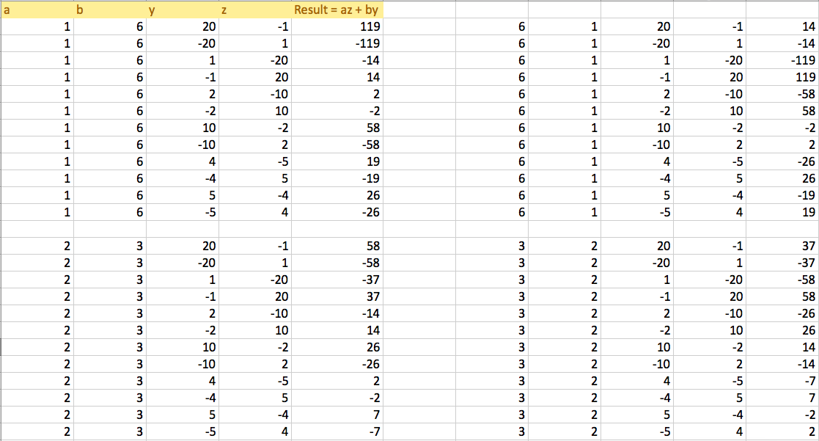
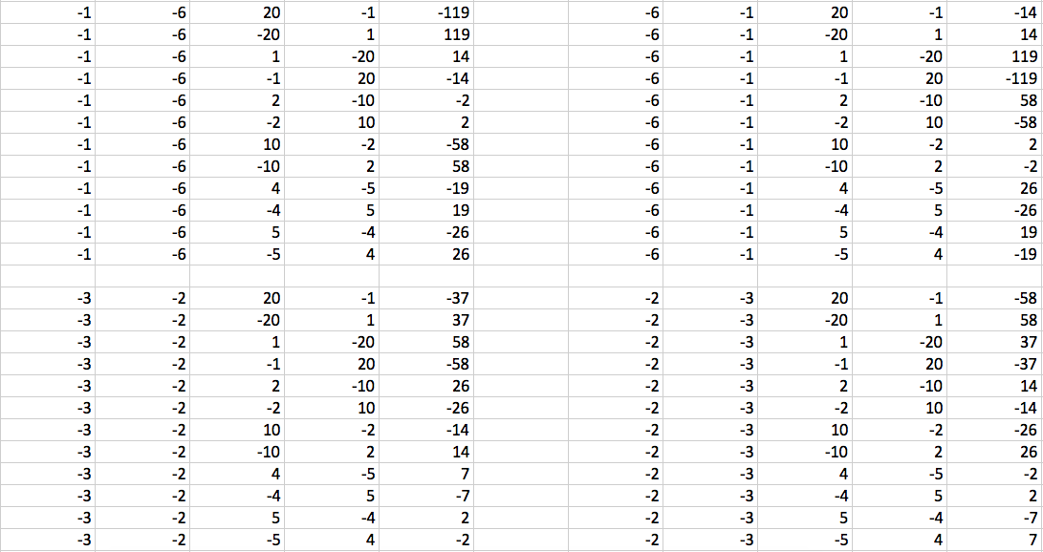

There are 8 factor pairs of 6, and 12 factor pairs of -20. $8×12=96$. However there are some repeated values, $96÷6 (a)=16.$

$$b=±119, ±58,±37,±26,±19,±14,±7,±2$$

2. This time, the constant is allowed to vary. How many quadratics of the following forms factorize with integer coefficients? Here, c is allowed to be any positive integer.

a.$x^{2}+6x+c$
In order to get the value of b (6x), when it is factorized in the form of $\left(x+y\right)\left(x+z\right)$, $y+z$ must equal to b (6).

- For c to be positive, both of the addition pairs have to be either positive $(y×z)$, or negative$(-y×-z)$.
- Repeating sums are disregarded
- Addition pairs of 6 itself plus 0 isn’t counted

The addition pairs for 6 are: $\left(1, 5\right), \left(2, 4\right),\left(3, 3\right)$

Solve for c ($c=y×z$)
1. $\left(x+1\right)\left(x+5\right), c=5$
2. $\left(x+2\right)\left(x+4\right),c=8$
3. $\left(x+3\right)\left(x+3\right),c=9$

$$c=5,8,9$$

b.$x^{2}-10x+c$
Addition pairs of -10 (both values must be negative, so when multiplied c is positive):$\left(-1, -9\right), \left(-8, -2\right),\left(-7, -3\right), \left(-6, -4\right), (-5, -5)$
$$c=9, 16, 21, 24, 25$$

c.${3x}^{2}+5x+c$
The addition pairs for 5 are:$\left(1, 4\right), \left(2, 3\right)$
However, to factorize in the form of$\left(3x+y\right)\left(x+z\right)$, one of the factors (z) must be a factor of 3.

In this case, only $\left(2, 3\right)$ has a factor of 3:
$$3x×1=3x,2×x=2x,$$
$$3x+2x=5x$$
$$\left(3x+2\right)\left(x+1\right)$$
$$c=2$$

d.${10x}^{2}-6x+c$
The addition pairs for -6 are:$\left(-1, -5\right), \left(-2, -4\right), (-3, -3)$
None of these addition pairs are multiples of 10, or both its factors.
There are no possible values for c.

3. What are the answers to question 2 if c is only allowed to be a negative integer?

In this case, there would be infinite answers to question 2.

For example, 2c: ${3x}^{2}+5x+c$
A possible addition pair for 5 where c is negative is $\left(6,-1\right)$.
$$\left(3x-1\right)\left(x+2\right)$$
c= -2

We can also express 5 as (9, -4), and (12, -7)…

When y is positive and z is negative (or vice versa), since there are an infinite amount of positive and negative values, there are an infinite amount of combinations that will result in $bx$ (in this case, 5).

4. Generalizing question 1, if c is a fixed integer, how many quadratics of the form $x^{2}+bx+c$ factorize with integer coefficients? Here, b is allowed to be any integer.

Possible b values = no. factor pairs for c
(To find the exact values to b, add the factor numbers in each pair)

- Disregard extra pairs giving the same sum, for example use either $(x+1)(x+10)$ or $(x+10)(x+1)$.

5. Further generalizing question 1, if a and c are fixed integers, with a positive, how many quadratics of the form ${ax}^{2}+bx+x$ factorize with integer coefficients? Again, b is allowed to be any integer.

The find the possible b values in the form${ax}^{2}+bx+x$, multiply the number of factor pairs for both a and c.

Possible b values = (no. factor pairs of c) $×$ (no. factor pairs of a)

6. How can we generalize question 2 or 3?

Question 2: No. values for b = amount of addition pairs for b (disregard repeating sums)
- At least on number in the addition pair (mod a) must be 0, otherwise, disregard the pair.

Question 3: There are an infinite amount of possible values of c, if it can only be negative. When written in the form of $(ax+y)(x+z)$, the number in the factor pair in the place of z must be a factor of a, and be divided by a.

