Maths Investigation.

How To Solve: “Two-Way-Functions”

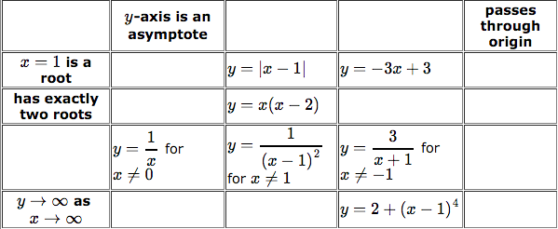
The task: To fill in the following table .

lthough 2 way functions aren’t a real thing , we have to plot functions via desmos to try and figure out the blank spaces.

The first step my group took was to try and figure out the headings as from there we could fill in the possibilities. We did this because all the headings are fixed they only have one possibility whereas the functions themselves have many possibilities.
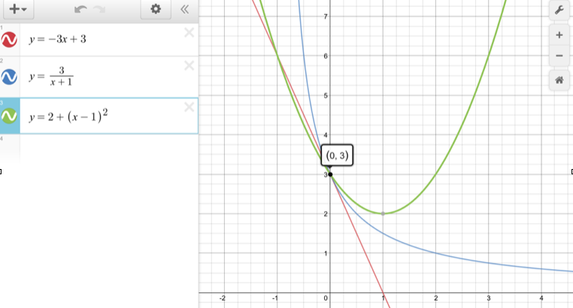
Firstly to find out the headings we input all of the given functions in that column/row into desmos Then we identified common features of these graphs. An example of this is the graph on the right where all Y-intercepts are 3. We did this with every column until they were all filled.

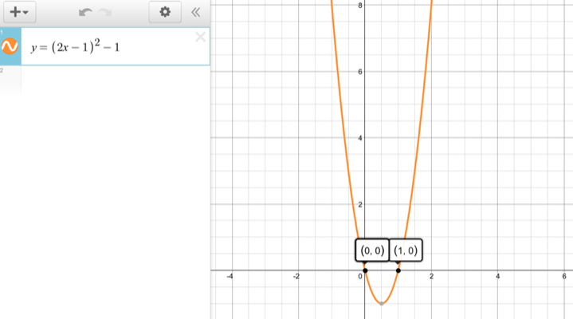
The next step was to find out what possibilities could be in the boxes. Firtsly we checked that allt eh function rules were valid and they all worked with eachother (eg: A Y-intercept asymptote could not have a common box with a function which was required to go through the X-intercept- As this doesn’t exist and is invalid.) For the function on the right (y=(2x-1)^2) -1 follows the rules that the function must have exactly two roots and it also passes through the origin. We found this by using other common functions already given to us and guess and check if all else fails. Once we have done this for all functions we checked that everything worked. (note there are many potential possibilities for each function)

Please find attached the completed 2-way-function table.
By Jay Patel.

Y=1/x+1 -1
Y=1/(x+1) -1
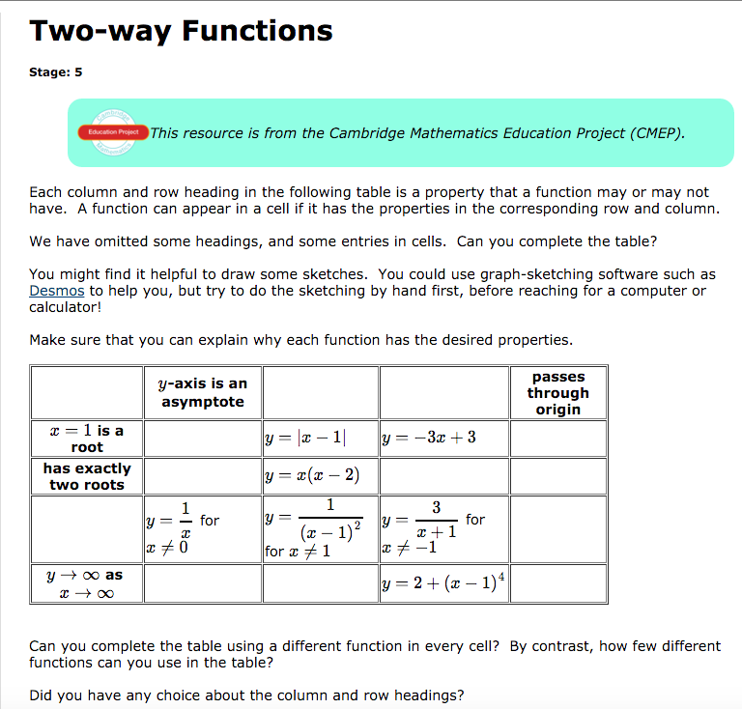

Line of symmetry is x=1
Y intercept = (0,3)
x-axis is an asymptote
Y=x^2
Y=(2x-1)^2 -1
Y=(2x-4)^2 -1
Y=(x-3)^2-6
Y=(x-1)^2
Y=2^x/x

Y=((1/x) – (2))((1/x)+2
Y=1/x - 1

