Towering Trapeziums:

OGH is an isosceles right-angled triangle:
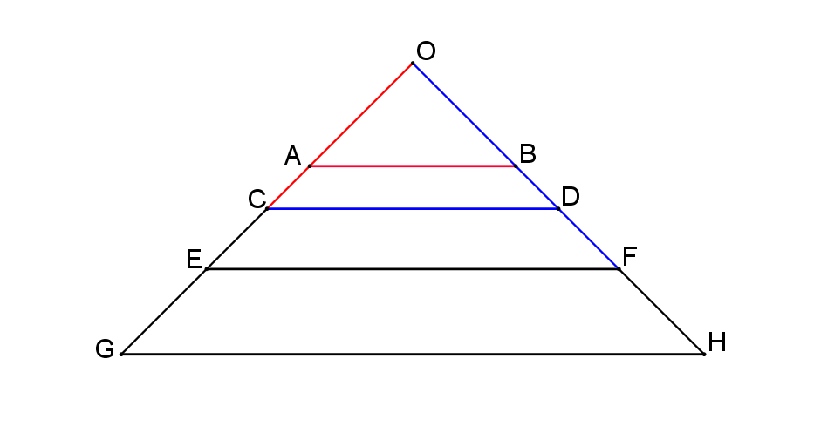
Lines AB, CD, EF, and GH are parallel.

Suppose the area of the smallest triangle OAB is one square unit.
- If lines OC and AB have the same length, calculate the area of trapezium ABDC.
It is one square unit because OCD = 2 square units and OAB = 1 square units.

- If lines OE and CD also have the same length, calculate the area of trapezium CDFE.
2 square units Because The triangle OEF = 4 square units. When you subtract that from OCD which is 2 you get the trapezium.

- If lines OG and EF also have the same length, calculate the area of trapezium EFHG.
You get 4 square units using the method shown in the 2 examples above.

Suppose that the chain of trapezia continued.

What would be the area of the nth trapezium in the chain?
2^n-1 2 to the power n-1

Can you explain your results?
They keep going up and you can tell that the trapezium is equal to half of the triangle it is inside. This is because it you draw a line in the middle of the first triangle, you will see that one half of the triangle is equal to the small triangle on top. When you subtract 1 from N that equals to the trapezium itself because we are subtracting the area of the triangle.

