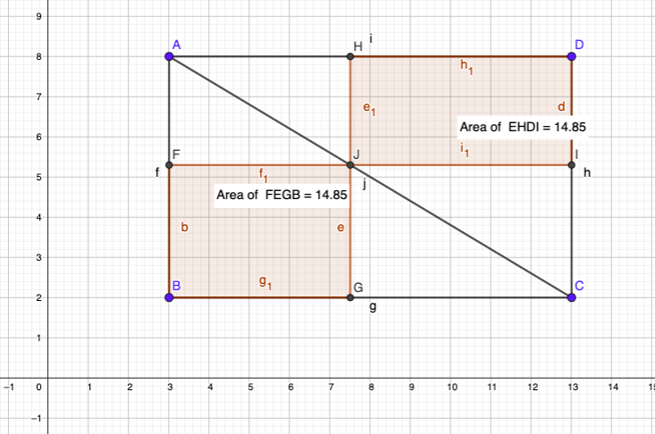
As in a rectangle a diagonal divides a rectangle in two congruent triangles of equal area.
Hence:
- Area triangle ABC = Area Triangle ADC
- Similarly GJIC is a rectangle , therefore Area triangle JGC =. Area triangle JIC
- Similarly AHJF is a rectangle, therefore Area triangle AFC = Area triangle AHJ

Now subtracting the sum of 2 and 3 from 1, we get
Area rectangle FBGJ = Area rectangle HJID

